

Enhanced Golf Swing Evaluation with MediaPipe

Mr. Pachara Temjai

THIS PROJECT IS PART OF THE STUDY OF THE BACHELOR OF SCIENCE IN
COMPUTER SCIENCE
DEPARTMENT OF COMPUTER AND INFORMATION SCIENCE
FACULTY OF APPLIED SCIENCE,
KING MONGKUT'S UNIVERSITY OF TECHNOLOGY NORTH BANGKOK
THE ACADEMIC YEAR 2024

Project Title : Enhanced Golf Swing Evaluation with MediaPipe
Name : Pachara Temjai
Major Field : Computer Science
Department : Computer and Information Science
Faculty : Applied Science
Project Advisor : Thattapon Surasak, Ph.D.
Academia Year : 2024

Accepted by the Department of Computer and Information Science, King Mongkut’s University of Technology North Bangkok, in partial fulfillment of the requirements for the Bachelor of Science in Computer Science

............................................................... Chairperson
(Assistant Professor xxxx xxxx, Ph.D.)
............................................................... Committee ............................................................... Committee
(Assistant Professor xxxx xxxx, Ph.D.) (Associate Professor xxxx xxxx, Ph.D.)
............................................................... Advisor
(Thattapon Surasak, Ph.D.)

............................................................... Head of Department of Computer and Information Science
(Assistant Professor Akara Prayote, Ph.D.)

Copyright of the Department of Computer and Information Science, Faculty of Applied Science, King Mongkut's University of Technology North Bangkok
The Academic Year 2024
Abstract

Golf requires precise coordination of body movements to achieve optimal performance and reduce injury risk. However, self-training poses challenges in identifying areas for improvement without professional guidance. This study presents an innovative approach to golf swing evaluation using computer vision and machine learning techniques. The research focuses on analyzing eight key phases of the golf swing: Address, Toe-Up, Mid-Backswing, Top, Mid-Downswing, Impact, Mid-Follow-Through, and Finish. Utilizing the MediaPipe framework, the system performs Human Pose Estimation on golf swing videos, extracting crucial body landmarks and joint angles. These features serve as input for various machine learning models, including Decision Tree, Random Forest, Long Short-Term Memory (LSTM), Gated Recurrent Unit (GRU), and One-Dimensional Convolutional Neural Networks (1D CNN), to classify the swing phases. The LSTM model, despite slightly lower accuracy than Random Forest, was chosen for its ability to handle sequential data effectively. The system then compares the user's swing against a baseline dataset of professional golfers, calculating similarity scores for each phase and joint angle. This comparison provides users with detailed feedback on their swing mechanics, highlighting areas for improvement. A user-friendly web application was developed to facilitate video uploads, automated analysis, and progress tracking. This comprehensive approach offers golfers a powerful tool for self-improvement, complementing traditional coaching methods and enhancing the effectiveness of practice sessions.

Keywords: Golf Swing Evaluation, Golf Swing Analysis, MediaPipe, Deep Learning, Computer Vision, Human Pose Estimation, LSTM.

Acknowledgements

This project was successful due to the knowledge of the academics at King Mongkut's University of Technology North Bangkok (KMUTNB).

I would like to express my sincere gratitude to Dr. Thattapon Surasak, whose dedicated efforts were instrumental in fostering cooperation between KMUTNB and the National Central University (NCU), enabling the successful realization of this project.

I extend my deep thanks to Professor Dr. Min-Te Sun at NCU for generously supporting and granting permission for the utilization of laboratory resources, which was crucial for the project's execution. I would also like to express my deep appreciation to Miss Kotcharat Kitchat for her invaluable support in coordinating between KMUTNB and NCU. Her dedication to managing the required paperwork and ensuring everything was organized played a significant role in making my internship a seamless experience.

Special acknowledgment goes to my mentor, Mr. Patcharawit Wilaikaew, whose unwavering guidance, insightful advice, and continuous support greatly influenced the development and documentation phases of this project. Their combined contributions have significantly enhanced the quality of the content to write this thesis.
Finally, I would like to thank my parents for supporting me in addition to my friends and everyone who provided advice, gave time, and helped in every aspect throughout this project.

Mr. Pachara Temjai

12 September 2024
TABLE OF CONTENTS
Page
Abstract ii
Acknowledgements iii
List of Tables vi
List of Figures vii
Chapter 1 Introduction 1
1.1 Background and Importance of the Project 1
1.2 Objective 2
1.3 Scope 3
1.4 Expected Benefits 3
1.5 Timeline 4
1.6 Report Outline 6
Chapter 2 Literature Review 7
2.1 Related Studies 7
2.2 Preliminary 9
Chapter 3 Methodology 14
3.1 Co-op Journey 14
3.2 Dataset Pre-processing 19
Chapter 4 System Development 33
4.1 Data preparation 34
4.2 Train model 41
4.3 Test model 45
4.4 Evaluate process 48
Chapter 5 Experimental 52
5.1 Dataset 52
5.2 Training 54
5.3 Evaluation metrics 57
5.4 Results and Discussion 59
5.5 Evaluation for web application 70
5.6 Web Application Overview 72
Chapter 6 Conclusion 79
6.1 Main Finding 79
6.2 Limitations 80
6.3 Problem encountered 81
6.4 Solution of the Problems 82
6.5 Personal achievements during Co-op 83
Bibliography 85

LIST OF TABLES
Table Page
Table 1-1 Gantt Chart 5
Table 3-1 Co-op Journey 19
Table 3-2 Key Body Points for Pose Estimation and Feature Extraction 23
Table 3-3 Use Case description: Sign up 30
Table 3-4 Use Case description: Login 31
Table 3-5 Use Case description: Logout 31
Table 3-6 Data dictionary: user 32
Table 3-7 Data dictionary: event 33
Table 5-1 Total videos in the dataset 54
Table 5-2 Summary of videos used in the study 55
Table 5-3 Model Evaluation Metrics (Real-time & Slow-Motion Data without Angular Features) 61
Table 5-4 Model Evaluation Metrics (Real-time & Slow-Motion Data with Angular Features) 61
Table 5-5 Model Evaluation Metrics (Real-time Data without Angular Features) 62
Table 5-6 Model Evaluation Metrics (Real-time Data with Angular Features) 63
Table 5-7 Sample Predictions from Random Forest Model and LSTM Model 70

LIST OF FIGURES
Figure Page
Figure 3-1 Examples of all 3 shooting angles 21
Figure 3-2 Pose landmarks 22
Figure 3-3 Before and After HPE process 23
Figure 3-4 Example of variable assignment 25
Figure 3-5 Golf Swing Sequences 26
Figure 3-6 System Architecture Overview 28
Figure 3-7 Login System Use Case Diagram 28
Figure 3-8 Evaluation System Use Case Diagram 29
Figure 3-9 ER Diagram 32
Figure 4-1 Organizing video by camera angles and video type 35
Figure 4-2 Video duration normalization process 37
Figure 4-3 Human Pose Estimation with MediaPipe process 39
Figure 4-4 Human Pose Estimation with MediaPipe process (2) 40
Figure 4-5 Train model 42
Figure 4-6 Train model (2) 43
Figure 4-7 Train model (3) 44
Figure 4-8 Test model on Base-line data 46
Figure 4-9 Evaluate process 49
Figure 4-10 Evaluate process (2) 50
Figure 5-1 Features correlation 57
Figure 5-2 Confusion matrix of Decision Tree 64
Figure 5-3 Confusion matrix of Random Forest 65
Figure 5-4 Confusion matrix of LSTM 66
Figure 5-5 Confusion matrix of GRU 67
Figure 5-6 Confusion matrix of 1D CNN 68
Figure 5-7 Homepage Before Login 74
Figure 5-8 Homepage Before Login (2) 74
Figure 5-9 Homepage Before Login (3) 75
Figure 5-10 Sign Up Page 75
Figure 5-11 Login Page 76
Figure 5-12 Homepage After Login 76
Figure 5-13 Video Upload Page 77
Figure 5-14 Video Upload Page (2) 77
Figure 5-15 Video Upload Page (3) 78
Figure 5-16 Video Upload Page (4) 78
Figure 5-17 History Page 79
Figure 5-18 History Page (2) 79

Chapter 1
Introduction

1.1 Background and Importance of the Project
Golf requires precise coordination of muscle groups throughout the body to accurately send the ball to the desired target. This coordination involves strength, flexibility, and synchronized movement of muscles throughout the body. Mastery of the golf swing requires consistent and correct practice to achieve both optimal performance and efficiency. A proper swing posture not only ensures accuracy and power in driving the ball but also significantly reduces the risk of injury, thereby protecting golfers from unnecessary strain or harm.
Despite its importance, self-training in golf swings presents several challenges. Many golfers struggle to fully understand the correct posture and often fail to recognize flaws in their technique during practice. Without the guidance of experienced coaches, identifying areas for improvement becomes a daunting task. These challenges can slow the process of skill development and undermine the effectiveness of training, creating barriers for golfers who aim to elevate their performance.
In recent years, advancements in computer vision have provided new opportunities for analyzing human movements, including sports-related actions, such as the golf swing, the tennis serve, and football shots. Computer vision technology enables machines to interpret and understand visual data, such as body posture and motion, with high precision. By leveraging this technology, it is possible to assess the nuances of a golfer's swing in real-time, providing detailed feedback on posture and technique. This emerging field is particularly valuable in sports, where precise body movements can significantly impact performance. Integrating computer vision into golf training enables more accurate and objective analysis, empowering golfers to better understand their strengths and weaknesses.
Based on these insights, the aim of this research project is to develop a system that evaluates golf swing postures using body posture assessment techniques and artificial intelligence. By incorporating computer vision into the analysis process, the model can offer golfers a powerful tool to enhance their practice and refine their techniques. Rather than replacing the role of professional coaches, this system seeks to complement traditional training by reducing the limitations posed by time and cost, allowing golfers to continuously improve their skills and reach new levels of performance.

1.2 Objective
1.2.1 Develop a Golf Swing Scoring System.
Our primary goal is to create a system that accurately evaluates and scores golf swings based on key body movements and posture. This system provides users with detailed feedback to improve their techniques.
1.2.2 Enhance the Quality of the Pipeline.
We aim to optimize the entire evaluation process, focusing on improving the accuracy and efficiency of the data pipeline. This includes refining the pre-processing steps, time normalization, and pose estimation to ensure precise results throughout the system.
1.2.3 Create a User-Friendly Web Application.
A user-friendly web application is developed to allow users to easily upload their swing videos, receive feedback, and access detailed performance insights. This platform focuses on accessibility and user experience.

1.3 Scope
1.3.1 Development of the Golf Swing Scoring System: Video clips uploaded by users are analyzed to calculate the angles of key body points during golf swings. The angles are then compared with data from professional golfers, and each angle is scored at various swing postures.
1.3.2 Pipeline Enhancement: The pre-processing phase focuses on data cleaning, ensuring that user-submitted golf swing videos are properly prepared for comparison with clips from professional golfers in the GolfDB database. This step enhances the system’s ability to accurately evaluate performance against professional standards.
1.3.3 Web Application Development: A user-friendly web application is developed to streamline the user experience for easy video uploads. The platform processes these videos, provides detailed feedback on swing posture, and offers performance insights. The focus is on ensuring accessibility and usability.

1.4 Expected Benefits
The expected benefits of this project are as follows:
1.4.1 Enhanced Swing Posture Assessment: The project aims to provide golfers with a model that utilizes advanced computer vision and AI techniques to assess their swing posture accurately.
1.4.2 Personalized Feedback for Improvement: The system offers golfers detailed feedback on specific aspects of their swing, helping them identify and correct mistakes. This contributes to improved performance and reduces the risk of injuries associated with improper posture. Personalized feedback is tailored to each golfer's swing, enabling targeted improvements and more effective training.
1.4.3 User-Friendly Interface: Developing a user-friendly web application ensures that golfers can easily access the assessment system, making it convenient for users to utilize the tool.
1.4.4 Contribution to Sports Technology Research: The insights gained from the project provide valuable information for future research and development in sports technology, potentially benefiting other sports as well.

1.5 Timeline
This section outlines the timeline and milestones of the project. It is essential to ensure that a study of this magnitude runs smoothly and effectively. A Gantt chart provides a comprehensive overview of the project’s timeline and task distribution, presenting a structured perspective of its duration, tasks, and interdependencies. It offers a clear roadmap for tracking progress, identifying potential bottlenecks, and
effectively overseeing deadlines.
Task | May | Jun. | Jul. | Aug. | Sep. | Oct.
Reviewing Literature
Cleaning and
Pre-processing Data
Model Training and
Testing
Result Analysis and Discussion
Web Application Development
Documenting and Reporting

Table 1-1 Gantt Chart

- Reviewing Literature: This phase involves a comprehensive review of related works, studies, and existing methodologies in the fields of golf swing analysis, computer vision, machine learning and deep learning. It provides the foundational knowledge and context required for the research.
- Cleaning and Pre-processing Data: This task focuses on searching for golf swing video clips within the GolfDB database for model training and testing. The data undergoes a pre-processing step to ensure it is optimized for model input, which includes time normalization and the application of the MediaPipe Holistic method for Human Pose Estimation.
- Model Training and Testing: This task involves training the developed model on the collected and pre-processed data, followed by testing the model's performance. This phase is crucial for evaluating the effectiveness of the chosen algorithms and approaches.
- Results Analysis and Discussion: This ongoing task involves evaluating the model's performance by analyzing training and testing outcomes, identifying discrepancies or patterns, and comparing results with benchmarks. Discussions help interpret findings, leading to necessary model adjustments and improvements to enhance accuracy and performance. This iterative process ensures continuous refinement of the system.
- Web Application Development: This phase involves building a user-friendly web interface to deliver the golf swing evaluation system, ensuring accessibility for end-users.
- Documenting and Reporting: This encompasses compiling all findings, methodologies, and analyses into a structured report. The report serves as a comprehensive document detailing every aspect of the research, from inception to conclusion.

1.6 Report Outline
This thesis consists of six chapters that are outlined as follows:
- Introduction: The introduction chapter contains the background and importance of the project in addition to the objectives, scope, expected benefits, and timeline of the project.
- Literature Review: The literature review consists of studies related to the project’s development, tools, and techniques used.
- Methodology: The methodology chapter contains the overall systems design, data collection for machine learning, the program running process, and the model training algorithm.
- System Development: The system development shows the core components of the experimental setup, showcasing the primary coding and algorithms utilized. Here, readers are provided an in-depth walkthrough of the essential code snippets.
- Experiment: The experiment represents the results of the model training using the confusion matrix and the overall systems development.
- Conclusion: The conclusion contains the main finding, limitations, problems encountered, solutions to the problems, and personal achievements during cooperative education.

Chapter 2
Literature Review
This chapter introduces studies related to the present project’s overall development.

2.1 Related Studies
Mcnally et al. [1] introduce GolfDB, which is a video database specifically designed for golf swing sequencing. This resource is highly valuable for training models used in golf swing analysis. The dataset specifically features professional golfers and includes high-quality video clips from tournaments and training sessions. It offers a detailed breakdown of the golf swing sequence. This breakdown covers key phases, including Address, Toe-Up, Mid-Backswing, Top, Mid-Downswing, Impact, Mid-Follow-Through, and Finish. However, GolfDB has certain limitations. Because it focuses on professional golfers, it does not fully represent the wide variety of swings performed by non-professionals. Additionally, the dataset relies on video footage captured during tournaments, leading to variability in both video quality and camera angles, which affects the consistency of keyframe annotations. Despite these challenges, GolfDB remains an essential resource. It plays a significant role in the development of advanced tools for analyzing golf swings. The dataset is accompanied by the SwingNet model, designed to exploit the dataset's comprehensive features. The dataset's structure emphasizes the identification of key golf swing phases. This structure facilitates in-depth analysis of swing mechanics and performance.
Perini E. [2] explores the feasibility of mobile phone-based 2D human pose estimation for golf swing analysis, drawing parallels to the role GolfDB plays in analyzing professional golfers' swings. The study develops a system that identifies key swing events, including toe-up, top, and impact. It also measures specific angles, including knee flexion and lateral bending, using BlazePose. A significant limitation of the work is the reliance on 2D data, which lacks depth perception, thereby reducing the accuracy of swing event detection. Moreover, the system primarily focuses on knee flexion and lateral bending. It neglects other critical metrics, including rotational angles, thus limits its comprehensiveness compared to more established systems such as GolfDB and SwingNet. Despite these limitations, Perini’s research represents a notable advancement in golf swing analysis through the application of 2D human pose estimation on mobile devices. The study also underscores the potential of real-time feedback. This feedback can enhance both the user experience and performance.
Zhang et al. [3] introduce a novel approach for evaluating golf swings through an automatic pose grading system based on monocular swing videos. The study utilizes 3D Human Pose Estimation (HPE) to extract body joint data from swing videos. It also employs Dynamic Time Warping (DTW) to align and compare movements between query and reference videos. The proposed system effectively addresses the challenge of providing accurate feedback to amateur golfers by comparing their swings to professional references. The system’s key strength lies in its use of DTW for temporal alignment. The approach accommodates variations in the timing of key events between different swings, allowing for robust swing evaluations even when the rhythm or pace of movements differs. The integration of 3D pose estimation further enhances the system’s ability to deliver detailed feedback by capturing more precise joint positions compared to 2D methods. The DHU-Golf Dataset serves as a significant resource for swing analysis. The dataset was collected from a golf class consisting of students after a semester of training, provides consistent swing motions for analysis. Its relatively small size compared to other datasets, along with the limited participant pool, impacts the system’s generalizability to a broader range of golfers and conditions. Despite these limitations, Zhang et al.’s work makes a significant contribution to sports technology. The DTW-based grading system offers a promising tool for amateur players. It allows them to improve their swing mechanics without the need for expensive equipment.
Liao et al. [4] propose AI Golf: Golf Swing Analysis Tool for Self-Training that aims to improve golf swing analysis using neural networks. The system compares two motion sequences to identify keyframes where significant differences occur between the user's swing and professional golfers. This comparison enables users to intuitively understand these differences and focus on improving their swing form. The method operates without prior knowledge or labeled data, adopting an unsupervised learning approach that synchronizes motions with varying timings and phases through a motion synchronizer. A motion discrepancy detector is then employed to highlight movement discrepancies. This is followed by a decoder that reconstructs intermediate human poses, focusing specifically on both the user's swing and the professional golfer's swing. These features provide users with a clear path for gradual improvement. The system effectively detects fine-grained differences between the user's motions and those of professional golfers, with potential applications in other sports and skill-training processes. Its ability to deliver real-time feedback for self-training underscores its practical value, bypassing the need for expensive equipment or professional coaching.

2.2 Preliminary
2.2.1 Libraries
2.2.1.1 MediaPipe
MediaPipe [5] is a flexible framework developed by Google for real-time, cross-platform human movement analysis using machine learning. It supports a variety of applications. These applications range from hand tracking to full-body pose estimation. The modular design of MediaPipe enables seamless integration into diverse fields, including augmented reality, fitness, and sports analytics.
The holistic method [6] within MediaPipe enhances pose estimation by simultaneously tracking the body, face, and hands. The proposed approach provides a comprehensive view of human motion. The technique is particularly useful in activities that require coordinated body movements, where the synchronization of different parts of the body is crucial for optimal performance. The holistic method enables detailed assessments that highlight subtle aspects of performance. These assessments lead to targeted improvements. Its accuracy and broad applicability make it valuable not only in sports but also across various fields, including healthcare and entertainment.
2.2.2 Machine Learning
2.2.2.1 The Decision Tree Classifier [7] is a supervised machine learning algorithm. It is used for both classification and regression tasks. It works by splitting a dataset into subsets based on the value of input features, forming a decision-tree structure. Each internal node denotes a decision based on a feature. Each branch signifies an outcome of that decision. Finally, each leaf node indicates a class label or regression outcome. Decision trees are easy to interpret and can handle both numerical and categorical data, making them a popular choice for various tasks.
2.2.2.2 Random Forest Classifier [8] is an ensemble learning method. It combines multiple decision trees to enhance prediction accuracy and robustness. It trains several decision trees on different subsets of the dataset and then aggregates their predictions through averaging (for regression) or majority voting (for classification). The random selection of features and data subsets during training helps reduce overfitting. It improves the model's adaptability to new data. Random forests are favored for their versatility, ease of use, and strong performance across various domains.
2.2.3 Deep Learning
2.2.3.1 Long Short-Term Memory (LSTM) networks [9] are a type of Recurrent Neural Network (RNN). These networks are designed specifically to model temporal sequences and long-range dependencies. LSTM overcomes the vanishing gradient problem commonly encountered in traditional RNNs by employing memory cells that retain information across extended periods. These memory cells utilize three types of gates: input gates, forget gates, and output gates. These gates manage the flow of information. This gating mechanism enables the network to learn from and retain patterns over long sequences, making LSTM particularly effective for tasks that involve sequential data, such as time series prediction and natural language processing.
2.2.3.2 Gated Recurrent Unit (GRU) networks [10] are another variant of RNN. GRU networks aim to improve performance in modeling sequential data. GRU simplifies the LSTM architecture by combining the input and forget gates into a single update gate. By employing a reset gate, GRU manages the incorporation of past information into the current state. This streamlined approach reduces the computational complexity of GRU while retaining the ability to capture long-range dependencies.
2.2.3.3 One-Dimensional Convolutional Neural Networks (1D CNN) [11] are designed for processing sequential data by applying convolutional filters along one dimension. 1D CNN focus on extracting features from sequences. These sequences can include time series or text. By sliding filters across the input sequence, 1D CNN can identify patterns and local dependencies within the data. This capability makes 1D CNN effective for sequence classification. It also enhances their performance in regression tasks.
2.2.4 Web Development
2.2.4.1 Back-end
Node.js [12] is a powerful, open-source, server-side runtime environment built on Chrome's V8 JavaScript engine. Since its inception by Ryan Dahl in 2009, Node.js has significantly advanced web development. It enables JavaScript to be utilized for server-side scripting, allowing developers to build dynamic web applications that are executed on the server. Node.js is recognized for its event-driven, non-blocking I/O model, which contributes to its efficiency and lightweight nature, particularly for data-intensive real-time applications distributed across multiple devices. Its extensive package ecosystem is managed through the Node Package Manager (NPM). This ecosystem provides a wide range of modules that support and enhance application development.
Express.js [13] is a minimalist web application framework built on top of Node.js, developed by TJ Holowaychuk in 2010. Express.js is designed to provide a robust set of features. These features are specifically intended for web and mobile applications. It simplifies the process of building web applications by offering a thin layer of fundamental web application features, without obscuring the core functionalities of Node.js. Express.js enables developers to create web applications and Application Programming Interfaces (APIs) efficiently. It provides tools to manage routes, handle requests and responses, and integrate middleware to enhance functionality.
2.2.4.2 Front-end
Vite [14] is a modern front-end build tool created by Evan You, designed to enhance the development experience for JavaScript frameworks. It leverages native ECMAScript (ES) modules for faster development. Additionally, it bundles only the necessary code for production. With its efficient Hot Module Replacement (HMR) system and its capability to manage large projects, Vite is a popular choice for developers seeking a responsive development environment.
React [15] was developed by Facebook and released in 2013. It is a popular JavaScript library for building user interfaces, particularly for single-page applications. React allows developers to create reusable UI components, enabling a declarative approach to constructing dynamic and interactive web applications. It highlights the use of a virtual Document Object Model (DOM). This approach optimizes rendering and improves application performance. When combined with Vite, React benefits from faster builds, seamless hot reloading, and a more efficient development process.
2.2.4.3 Database
Structured Query Language (SQL) [16] is the standard programming language.
It is employed to manage and manipulate relational databases. Developed in the 1970s by IBM, SQL is fundamental to systems such as MySQL, PostgreSQL, SQLite, and Microsoft SQL Server. It enables developers to perform essential operations, including querying, updating, inserting, and deleting records. These operations are crucial for maintaining data integrity and accessibility in web development.
In web development, SQL databases store and manage persistent data, such as user information and transaction records. The ability to construct complex queries and manage relationships between tables makes SQL vital. This capability is essential for building robust and scalable applications.

Chapter 3
Methodology
In this chapter, the study is delineated, encompassing the methodology employed for dataset preparation and the specifications of the utilized models.

3.1 Co-op Journey
During my 6-month internship abroad, I had the opportunity to travel to Taiwan.
I commenced work the day following my arrival.
In May, I began by studying related papers. I carefully examined the advantages and disadvantages of various pose estimation models, focusing on MediaPipe [5] and OpenPose [17]. After a thorough evaluation, MediaPipe emerged as the preferred choice for our project due to its more efficient use of computational resources. Despite offering performance and capabilities comparable to OpenPose, MediaPipe has lower resource consumption. This makes it a more viable option.
In June, after studying other papers, I came across a dataset of golf swings from GolfDB that contains 1,400 clips of professional golfers, with a resolution of 160x160, and includes various camera positions such as down-the-line, face-on and others. Additional attributes in the dataset include video ID, golfer name, gender, and video clip type (real-time or slow-motion). The dataset also contains the exact frame of each event within the golf swing. With the dataset available, I began the prototyping process, passing the clips through the HPE process with MediaPipe, adjusting parameters to observe differences in results, and studying the outcomes. In the middle of June,
I started a two-month Chinese language course. I attended classes from Monday to Friday between 9:00 AM and 12:00 PM. After finishing class each day, I shifted my focus to my project until 5:00 PM.
In July, after studying MediaPipe and trying to prototype with the GolfDB dataset, I tried to follow the workload that I had planned Table 1-1. In GolfDB, the SwingNet model is employed. It is designed to analyze swing postures from clips of professional golfers. The results of the SwingNet model demonstrate an average accuracy of 76.1%. However, the performance varies significantly across swing positions. The Address position achieves only 31.7% accuracy, while the Finish position is even lower at 26.5%. In contrast, the six intermediate swing phases Toe-Up (84.2%), Mid-Backswing (88.7%), Top (83.9%), Mid-Downswing (98.1%), Impact (98.4%) and Mid-Follow-Through (97.6%) demonstrate much higher accuracy. These phases benefit from clearer and more distinct movements. This allows the model to better distinguish between them. The analysis suggests that the variation in clip duration contributes to the model's inconsistent performance across swing positions. To address this, the workflow begins by categorizing the GolfDB clips dataset. The categorization is based on shooting angles. The three primary angles down-the-line, face-on, and other were initially considered, but the "other" angle was excluded due to its excessive variability. Additionally, slow-motion clips were removed. These clips were simply real-time clips that had been stretched to create a slow-motion effect. Following this refinement, the process focuses on standardizing video durations. By calculating the total length of all videos, I determined the mean value, which was approximately 8.76 seconds. This standard duration was established to address the variability in clip lengths, as the dataset contained real-time videos of different lengths, leading to an asymmetric distribution. The mean was selected as a reliable measure for standardization and better represents the overall distribution. After studying Chinese for several weeks, I could clearly see the difference. I was able to understand Chinese. I could also have a basic conversation when I went shopping for food. This was beneficial thing for practicing a third language.
In August, I completed my Chinese language course around the middle of the month. I also took a proficiency test to ensure I met the required standards.
I am pleased to say that I passed the test successfully. Building on this progress, I began creating the model. I experimented with feature extraction methods to improve performance, reaching conclusions by applying trigonometric principles, particularly the use of the arctangent function to calculate the angle between two vectors, a method commonly found in textbooks and research papers. Then, it was time for the step of HPE using the MediaPipe tool. The holistic method was employed to evaluate the body posture of each clip. This method also stored the x and y positions of each key point. After establishing the formula for calculating the degree angle, the result indicates that the degree angle can be calculated for the left shoulder, right shoulder, left elbow, right elbow, left hip, right hip, left knee, and right knee. As a result, these angle values and coordinate positions of the wrist are considered as features.
Because the wrist is also an important point of the body in the golf swing and increases the variety of data in the training model. Then, we compare the results from the Decision Tree Classifier, Random Forest Classifier and the deep learning model, which is based on the SwingNet from GolfDB. The LSTM model is used in the modeling process, so it is brought in for comparison. In addition, there are GRU and 1D CNN models that possess properties similar to LSTM. The comparison showed that the Random Forest Classifier achieved the highest accuracy of 94% when trained with Down-the-line and Face-on angles. However, the LSTM model is specifically designed for analyzing sequential data. Therefore, it is more appropriate for examining the phases of a golf swing. Its capacity to learn temporal patterns across swing positions provides an advantage in capturing movement dynamics, despite its slightly lower accuracy of 92%.
In September, I developed a model for predicting the eight golf swing postures. After completing this, I returned to the process of adjusting video length based on both down-the-line and face-on angles. This dataset is then used as input for the posture prediction model. It serves as a baseline for comparing user scores.
The pipelines began by taking the user's clip and adjusting the video length to the mean value. Then feed into the HPE using the MediaPipe Holistic Method. Next, the angle values of key body points are calculated and stored in a CSV file. After that, the data is input into the pose prediction model. The user data is compared with the baseline data using Euclidean distance to identify similar values. This comparison is then presented as a percentage for each of the eight poses. An average value is also provided to facilitate visualization for the user. In summary, I completed the Base-Line process, the user process, and in parallel with developing a website to display the results for users.
In October, the final month, my focus was on reviewing all documentation.
I ensured that the documentation met the required standards for presentation or future use. A summary of monthly activities and milestones is presented in Table 3-1, highlighting the key tasks and adjustments throughout the co-op journey.

Month | Tasks/Activities | Skills Acquired/Developed | Challenges Encountered
May | - Studied related papers and MediaPipe for Human Pose Estimation.  - Compared MediaPipe with OpenPose and AlphaPose.  - Selected MediaPipe as the primary tool. | - Research methodology and comparative analysis of models.  - Familiarity with MediaPipe for pose estimation. | - Decision-making challenge: choosing the most suitable model among various options.
June | - Obtained GolfDB dataset for professional golf swings.  - Prototyped with MediaPipe to process swing clips.  - Experimented with adjusting MediaPipe parameters for better results. | - Practical experience with dataset handling.  - Deepened understanding of HPE using MediaPipe. | - Faced difficulties with varying clip lengths causing asymmetric data distribution.  - Adjusted video length calculation methodology.
July | - Explored SwingNet model from GolfDB.  - Separated data based on shot angles.  - Adjusted video lengths to a consistent mean value.  - Developed a unique approach using trigonometry for angle calculation. | - Gained knowledge of trigonometric functions and their application in angle calculation.  - Hands-on experience with data pre-processing. | - Handling time discrepancies due to different clip lengths.  - Difficulty in ensuring consistent data distribution.
August | - Started model development using trigonometric angle calculations.  - Conducted Human Pose Estimation using MediaPipe.  - Selected key body points and calculated angle features.  -Training models: Decision Tree Classifier, Random Forest Classifier, LSTM, GRU, and 1D CNN. | - Enhanced understanding of model training and evaluation.  - Familiarity with machine learning and deep learning models for classification tasks | - Computational limitations while training models.  - Discarded less consistent angles due to posture variability.
September | - Finalized model for predicting eight golf swing postures.  - Developed a Base-Line model for comparison.  - Processed user data for posture prediction.  - Implemented Euclidean distance for result comparison.  - Began web development to display prediction results. | - Practical application of Euclidean distance in model evaluation.  - Gained experience in web development for results presentation. | - Ensuring accurate comparison between Baseline and user data.  - Managing parallel tasks: model development and web implementation.
October | - Conducted a comprehensive review of all processes from start to finish.  - Finalized documentation and prepared project reports | - Refinement of project management and documentation skills.  - Attention to detail in the verification of processes. | - Ensuring all processes are thoroughly checked and documented accurately.  - Managing time effectively to meet final deadlines.
Table 3-1 Co-op Journey

3.2 Dataset Pre-processing
After obtaining the dataset [section 5], we focus on two primary angles. These angles are Down-the-line and Face-on. This focus is necessitated by the presence of numerous other shooting angles. The variability in camera perspectives from other angles can significantly impact the training process. It can also affect other aspects of the analysis.

3.2.1 Human Pose Estimation
This section evaluates the human pose of professional golfers during their swings using the GolfDB dataset. We compare OpenPose and MediaPipe. This comparison justifies the selection of MediaPipe for this analysis.
OpenPose developed by Carnegie Mellon University, utilizes deep learning to detect and track human body movements with high accuracy. It identifies numerous key points. This capability is valuable for detailed motion analysis. However, OpenPose's substantial computational demands and complexity can be challenging for real-time analysis and deployment on devices with limited processing power.
MediaPipe was developed by Google. It offers a fast-processing and lightweight solution. This makes it suitable for devices with constrained resources.
It has been effectively used in applications such as yoga posture correction [18] and dance [19].

MediaPipe and Holistic Pose Estimation:
We employ the MediaPipe Holistic Method for this analysis. This method integrates advanced computer vision techniques. It detects and tracks the full body's pose. Key landmarks include the shoulders, elbows, hips, knees, and ankles.
This method offers a comprehensive view of the golfer's movements throughout the swing, providing a detailed and accurate representation.
GolfDB Dataset and Pipelines:
- The GolfDB dataset comprises video clips of professional golfers performing various swings.

The clips are organized into two primary pipelines based on camera angles:
Down-the-Line Angle (Figure 3-1 (a)):
- This angle captures the swing from a side view. It is directly along the line of the shot. It provides detailed insights into the golfer's body position, swing path and club movement relative to the ball.
Face-on Angle (Figure 3-1 (b)):
- This angle records the swing from a head-on perspective. It provides a direct view of the golfer's stance and motion. It is essential for analyzing the golfer's posture, alignment and follow-through, as it shows the body and club interact with the ball from the front.
By analyzing pose data from both Down-the-Line and Face-on angles using MediaPipe, we gain valuable insights. These insights pertain to the golfer's technique and performance.

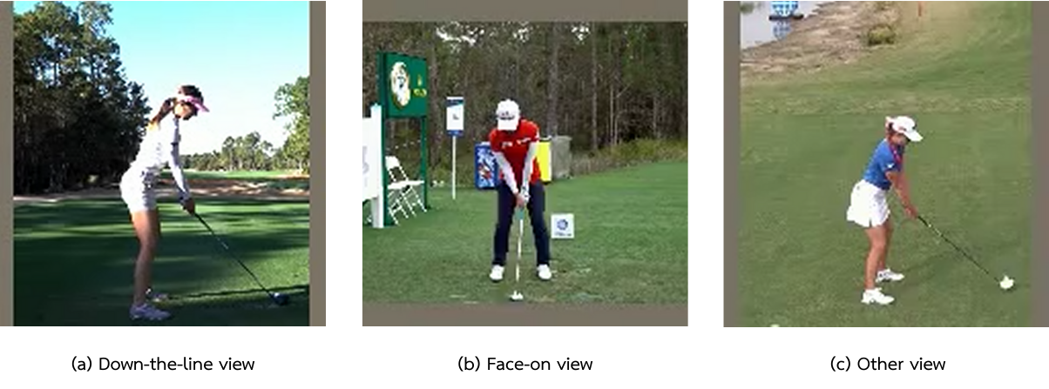
Figure 3-1 Examples of all 3 shooting angles

3.2.2 Feature Extraction and Angular Measurements:
In our analysis, we extract a comprehensive set of features from the MediaPipe Holistic Method output. These features include temporal information, positional data and angular features of key body landmarks as shown in Figure 3-2:

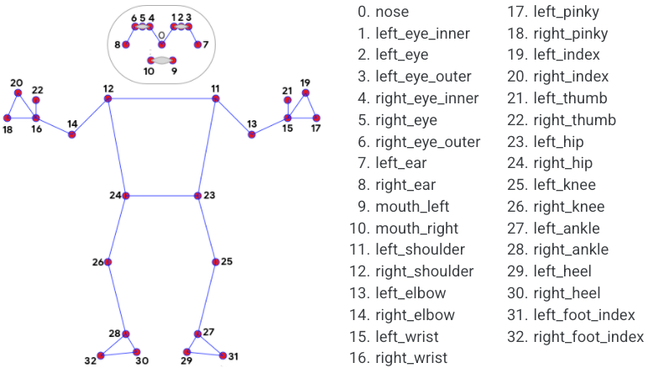
Figure 3-2 Pose landmarks

3.2.2.1 Temporal Information:
- Frame number
- Time stamp

3.2.2.2 Positional Data:
We extracted the x and y coordinates for key body landmarks using the MediaPipe tool with the holistic method to evaluate the body posture of each clip as shown
in Figure 3-3. These coordinates serve as features for future analysis.
The key body points and their corresponding features are as follows in Table 3-2:

BODY PARTS | FEATURES | BODY PARTS | FEATURES
nose | x, y nose | right ankle | x, y right ankle
left shoulder | x, y left shoulder | left wrist | x, y left wrist
right shoulder | x, y right shoulder | right wrist | x, y right wrist
left elbow | x, y left elbow
right elbow | x, y right elbow
left hip | x, y left hip
right hip | x, y right hip
left knee | x, y left knee
right knee | x, y right knee
left ankle | x, y left ankle
Table 3-2 Key Body Points for Pose Estimation and Feature Extraction

These positional data points are presented in Table 3-2 to track the precise movement of each body part during the golf swing. By combining the angular measurements with the positional data, we created a comprehensive dataset that captures the nuances of each golfer's swing mechanics. This detailed information enables us to perform in-depth analyses for a better understanding of swing techniques.
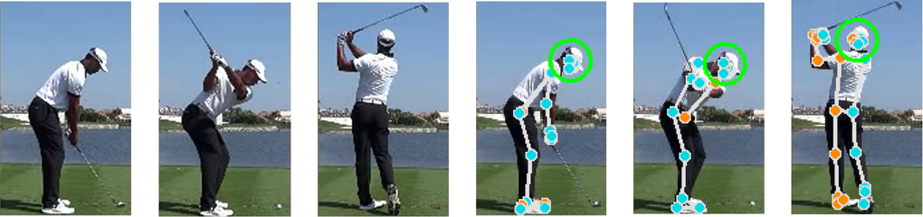
Figure 3-3 Before and After HPE process

3.2.2.3 Angular Features:
Angular features refer to the calculated angles between key body joints, derived from the x and y coordinates of body landmarks extracted through Human Pose Estimation. These include:
- Left and Right Shoulder Angles
- Left and Right Elbow Angles
- Left and Right Hip Angles
- Left and Right Knee Angles
These angular features provide crucial information about the golfer's body positioning and joint articulation throughout the swing. To calculate these angles, we employ the angle calculation formula (1). The variables in this formula can be interpreted as follows, with reference to Figure 3-4:

$angle=\left|\left(\arctan\left(​\frac{cy-by}{cx-bx}​​\right)-\arctan\left(\frac{ay​-by}{ax​-bx}​​​\right)\right)×\frac{180}{π}\right|​​$(1)

- (ax, ay) represents the x and y coordinates of the left shoulder joint.
- (bx, by) represents the x and y coordinates of the left hip joint.
- (cx, cy) represents the x and y coordinates of the left knee joint.

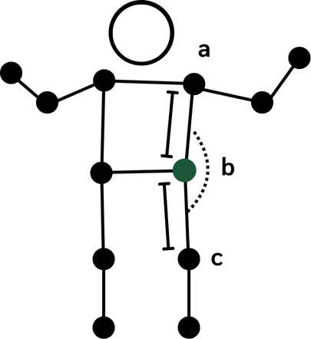
Figure 3-4 Example of variable assignment

3.3 Pose Classification Analysis
In this section, we present a comprehensive analysis of the models used for classifying golf swing poses based on the angles derived from the calculations outlined in Section 3.2.2.3. These angles serve as features for training the model to predict eight specific golf swing poses, which include: Address (A), Toe-Up (TU), Mid-Backswing (MB), Top (T), Mid-Downswing (MD), Impact (I), Mid-Follow-Through (MFT), and Finish (F). These poses are referenced in Figure 3-5.
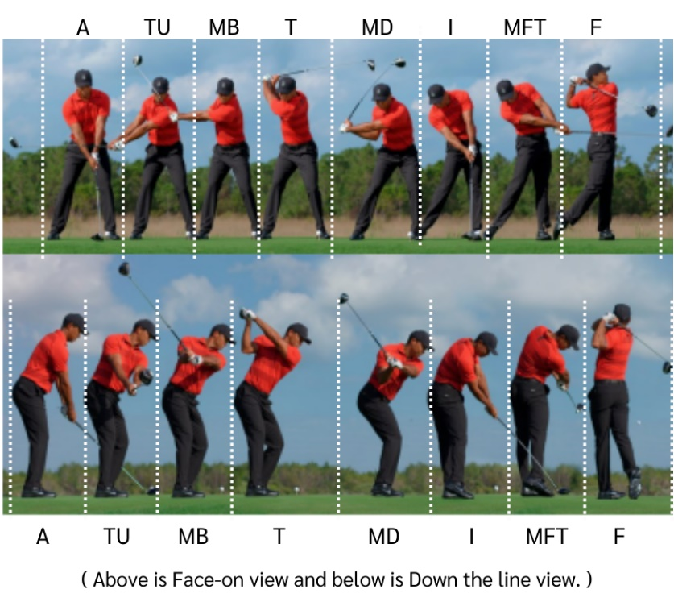
Figure 3-5 Golf Swing Sequences

3.3.1 Model Comparison
For a comprehensive analysis, we have employed a range of machine learning and deep learning algorithms, including Decision Tree Classifier, Random Forest Classifier, Long Short-Term Memory (LSTM), Gated Recurrent Unit (GRU), and One-Dimensional Convolutional Neural Network (1D CNN). Each of these models exhibits distinct characteristics. The characteristics are as follows:
3.3.1.1 Decision Tree Classifier
- Employs a decision tree structure where decisions are made at each node. This model is straightforward and interpretable. However, it struggles with complex data due to overfitting.
3.3.1.2 Random Forest Classifier
- Combines multiple decision trees to improve accuracy and reduce overfitting. It aggregates the results of various trees through averaging or voting. It enhances robustness.
3.3.1.3 Long Short-Term Memory (LSTM)
- Designed to handle sequential data by employing mechanisms for long-term and short-term memory. It is suitable for tasks that require an understanding of data context. This is especially important over time.
3.3.1.4 Gated Recurrent Unit (GRU)
- GRU shares similarities with LSTM but features a simplified internal structure. It employs gating mechanisms to manage sequential data. Typically, it demonstrates reduced training time requirements compared to LSTM.
3.3.1.5 One-Dimensional Convolutional Neural Network (1D CNN)
- Employs convolution operations tailored for 1D sequential data. It effectively extracts relevant features from sequential inputs. This is achieved through convolutional filters.

3.4 Web Application Design
3.4.1 System Architecture Overview (Figure 3-5):
3.4.1.1 Users: Being accessible to everyone, users can participate in the system through the front-end, whether it is observing the operation or actively uploading video for evaluation.
3.4.1.2 Front-end: The front-end serves as the user interface, with a focus on user-friendly design and intuitive navigation, it ensures a smooth user experience.
3.4.1.3 Back-end: The back-end forms the system’s backbone, handling the secure storage of processed videos in the database.
3.4.1.4 Database: At the nucleus of data management, the Database securely preserves user data, ensuring organized retrieval and fortifying data integrity.

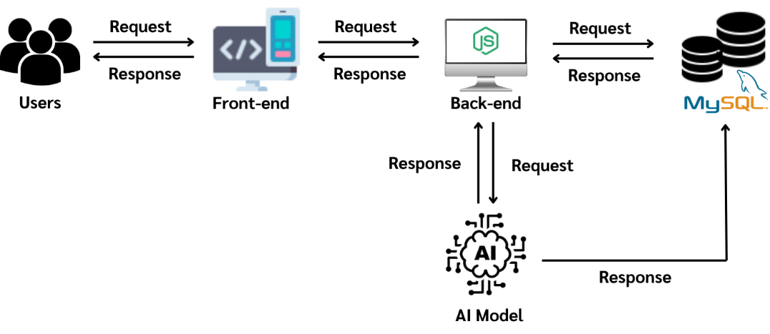
Figure 3-6 System Architecture Overview

3.4.2 Use Case Diagram
3.4.2.1 Login System (Figure 3-6)
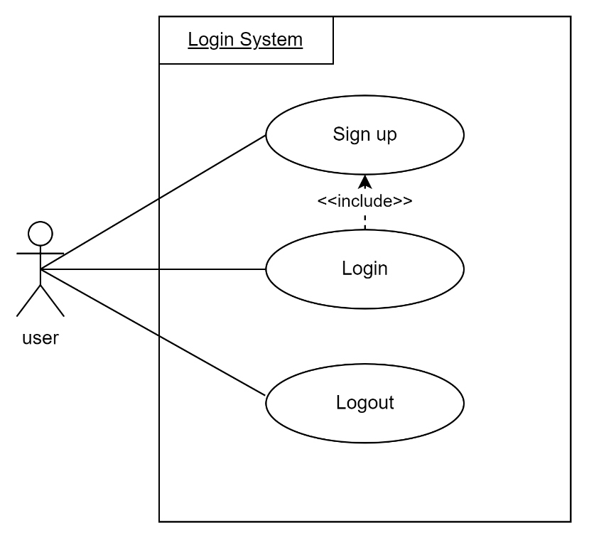
Figure 3-7 Login System Use Case Diagram

3.4.2.2 Evaluation System (Figure 3-7)
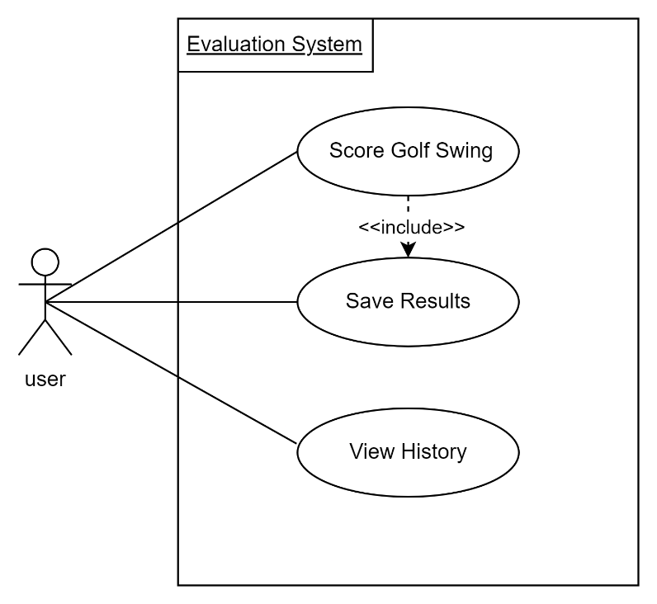
Figure 3-8 Evaluation System Use Case Diagram

3.4.3 Use Case Description
3.4.3.1 Login System
Use Case Number | 1
Use Case Name | Sign up
Brief Description | This use case allows a new user to create an account in the system.
Actors | User
Precondition | None
Main Flow | Actor | System
Main Flow | 1. User navigates to the registration page.  2. User enters required information (e.g., username and password). | 3. System validates the entered information.  4. If information is valid, the system creates a new account.
Alternate Condition | If entered information is invalid or username already exists, system displays an error message and asks the user to correct the information.
Table 3-3 Use Case description: Sign up

Use Case Number | 2
Use Case Name | Login
Brief Description | This use case allows a registered user to log into the system.
Actors | User
Precondition | The user has a registered account.
Main Flow | Actor | System
Main Flow | 1. User navigates to the login page.  2. User enters their username and password. | 3. System verifies the credentials.  4. If credentials are valid, system grants access and redirects to the home page.
Alternate Condition | If credentials are invalid, system displays an error message and prompts the user to try again.
Table 3-4 Use Case description: Login
Use Case Number | 3
Use Case Name | Logout
Brief Description | This use case allows a logged-in user to log out of the system.
Actors | User
Precondition | The user is currently logged in.
Main Flow | Actor | System
Main Flow | 1. User clicks on the logout option. | 2. System terminates the user's session.  3. System redirects the user to the login page or home page.
Alternate Condition | None
Table 3-5 Use Case description: Logout
3.4.4 Entity-Relationship (ER)
3.4.4.1 ER Diagram (Figure 3-8)
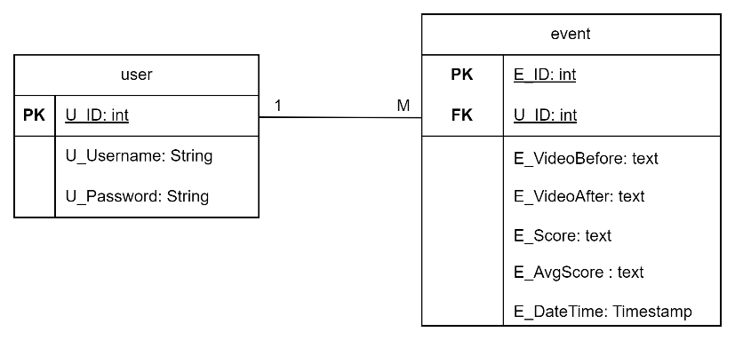
Figure 3-9 ER Diagram

3.4.5 Data Dictionary
Attribute | Data type | Description | Key
U_ID | Int | ID of the username. | Primary Key
U_Username | String | Username
U_Password | String | Password
Table 3-6 Data dictionary: user

Attribute | Data type | Description | Key
E_ID | Int | ID of the event | Primary Key
U_ID | Int | ID of the user | Foreign Key
E_VideoBefore | Text | Path specifying the directory storing the input video clip
E_VideoAfter | Text | Path specifying the directory storing the output video clip
E_Score | Text | Grading scores for each of the eight golf swing positions
E_AvgScore | Text | Average score of all eight golf swing positions
E_DateTime | Timestamp | Date and time when this event occurred
Table 3-7 Data dictionary: event

Chapter 4
System Development
This chapter shifts the focus towards the technical implementation of the research, providing a comprehensive examination of the code utilized in the project. While the previous chapters emphasized broader concepts, methodologies, and findings, this section delves into the detailed coding processes that powered the experiments and analyses.
The success of a research project is determined not only by its theoretical foundation but also by the precision of its coding implementation. This chapter breaks down the key components of the system. It covers critical aspects such as data pre-processing techniques and augmentations employed to enhance the dataset’s quality, alongside the selection of machine learning models, deep learning models, algorithms, and evaluation metrics.
Each element is explained in detail, ensuring that the rationale behind every decision is clear. In addition to high-level insights, the chapter provides a line-by-line analysis of the code, with explanations accompanying every critical section. This approach ensures that both the overarching logic and the finer technical details are well understood.
To further enhance comprehension, figures and diagrams are carefully integrated throughout, offering visual representations that clarify the code’s role in supporting the research objectives. These visual aids, combined with thorough explanations, provide a clear understanding of the code’s contribution to the project’s overall success.

4.1 Data preparation
4.1.1 Organizing video by camera angles and video type
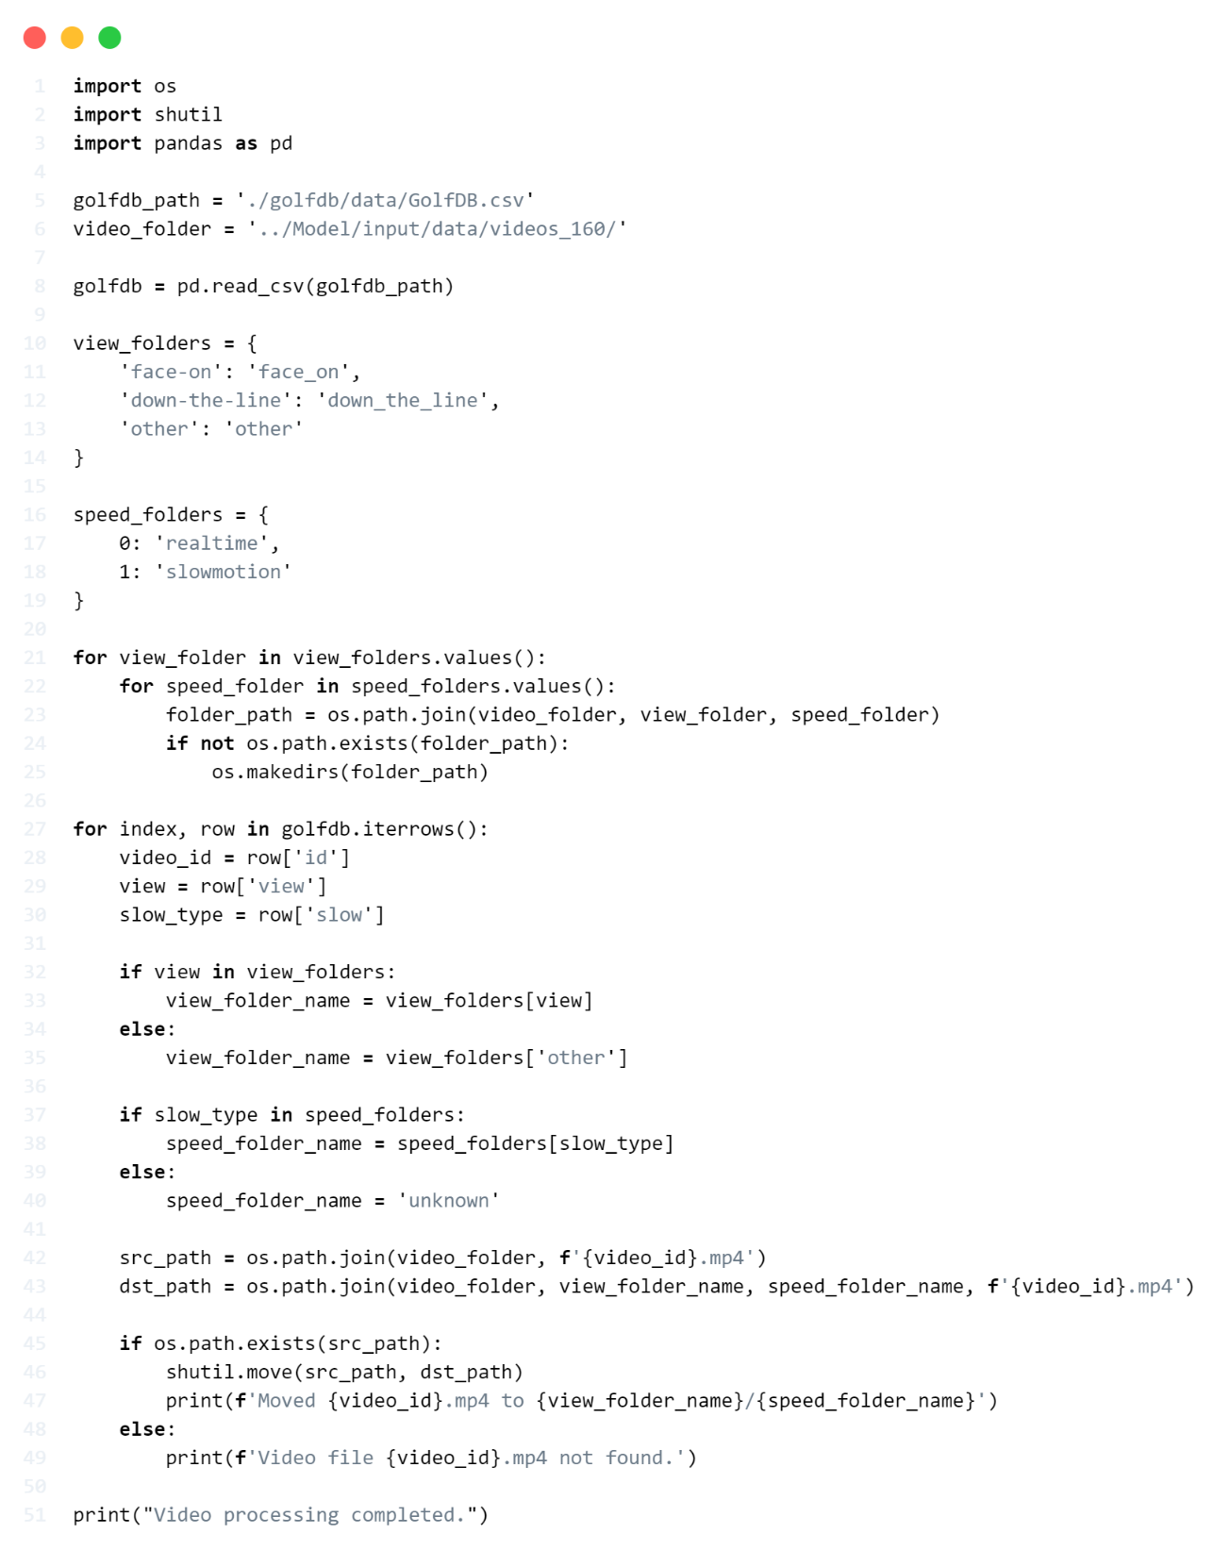
Figure 4-1 Organizing video by camera angles and video type

Lines 1-3 Necessary imports: os for file operations, shutil for file moving, and pandas for data manipulation.
Lines 5-6 Define paths for the GolfDB CSV file and the video folder.
Line 8 Read the GolfDB CSV file into a pandas DataFrame.
Lines 10-14 Define a dictionary 'view_folders' mapping view types to folder names.
Lines 16-19 Define a dictionary 'speed_folders' mapping speed types (0 and 1) to folder names.
Lines 21-26 Nested loops to create folder structure:
- Outer loop iterates through view types.
- Inner loop iterates through speed types.
- Create folders for each combination if they do not exist.
Lines 27-50 Main processing loop:
- Iterate through each row in the GolfDB DataFrame.
- Extract video ID, view type, and slow-motion type.
- Determine the appropriate view and speed folder names.
- Construct source and destination paths for the video file.
- If the source file exists, move it to the destination folder.
- Print a message indicating the file movement or if the file was not found.
Line 51 Print a message indicating that video processing is complete.

4.1.2 Video duration normalization process
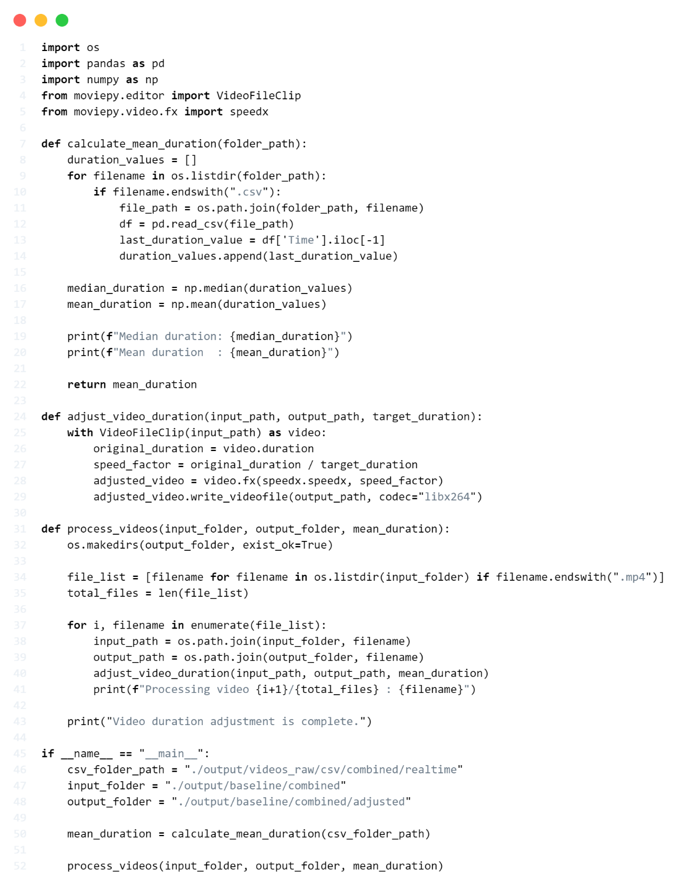
Figure 4-2 Video duration normalization process

Lines 1-5 Import necessary libraries: os for file and folder operations, pandas and numpy for data manipulation, and moviepy for video editing.
Lines 7-22 Function calculate_mean_duration to compute the mean duration of videos.
Lines 8-9 Initialize an empty list to store duration values.
Lines 10-15 Loop through all CSV files in the specified folder, read the last time value from each file, and store in the list.
Lines 17-18 Calculate the mean of the duration values.
Lines 20-21 Print the calculated mean durations.
Line 22 Return the mean duration.
Lines 24-29 Function adjust_video_duration to adjust video speed to achieve the desired duration.
Line 25 Open the video file using VideoFileClip.
Lines 26-27 Calculate the speed_factor to adjust video speed.
Line 28 Adjust the video speed using the speedx function.
Line 29 Save the adjusted video as a new file.
Lines 31-42 Function process_videos to process all videos in the specified folder.
Line 32 Create the output folder if it does not exist.
Line 34 Create a list of all MP4 files in the input folder.
Line 35 Count the total number of files to process.
Lines 37-40 Loop through each video file and call the adjust_video_duration function.
Line 42 Display a message when processing is complete.
Lines 44-51 Main section of the program.
Lines 45-47 Define paths for various folders.
Line 49 Call calculate_mean_duration function to find the mean duration.
Line 51 Call process_videos function to process all videos.

4.1.3 Human Pose Estimation with MediaPipe process.
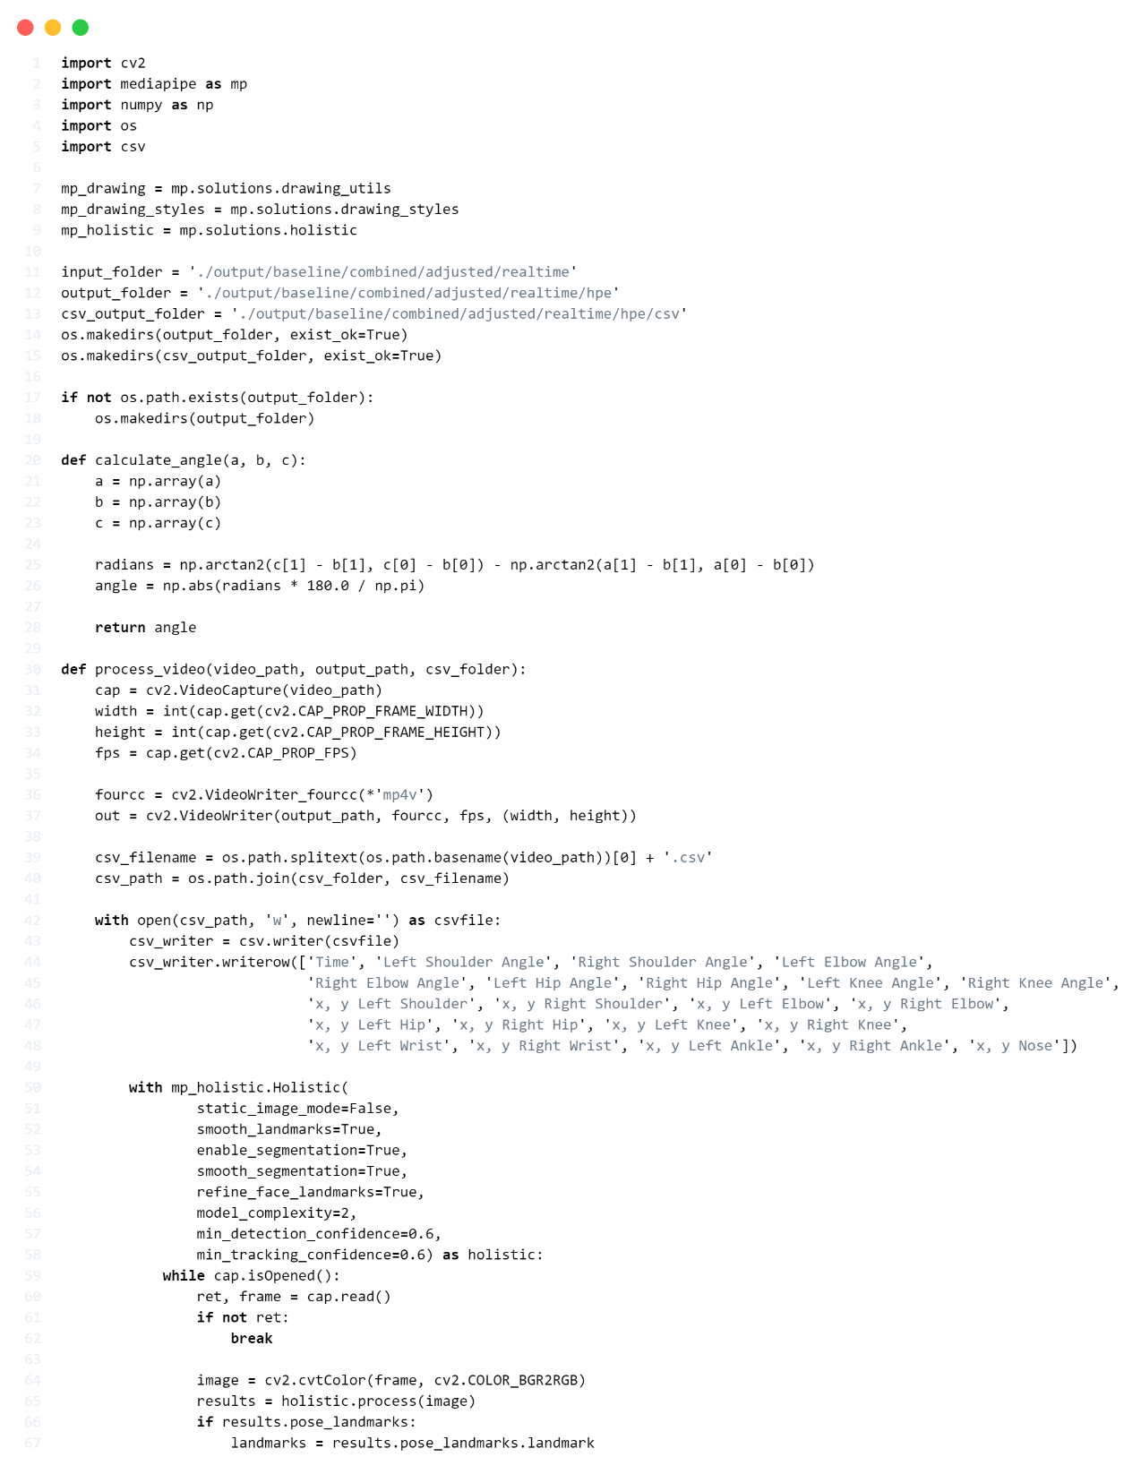
Figure 4-3 Human Pose Estimation with MediaPipe process
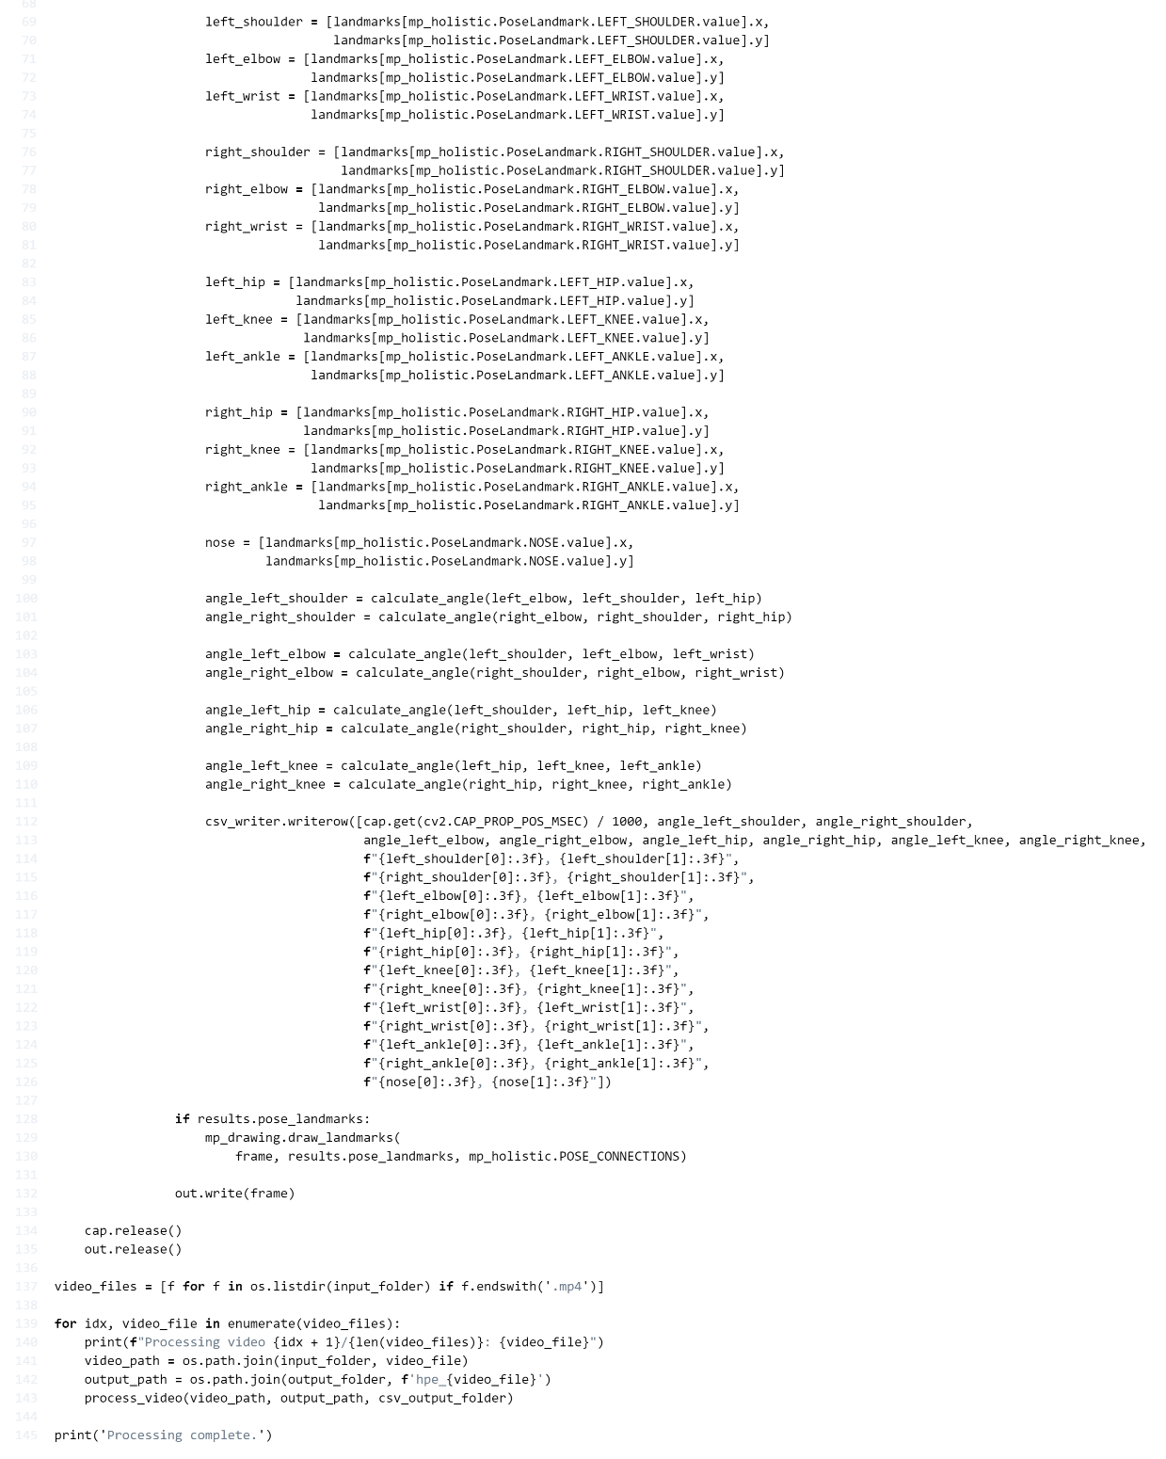
Figure 4-4 Human Pose Estimation with MediaPipe process (2)
Lines 1-9 Import necessary libraries and modules:
- cv2 for image processing.
- mediapipe for pose estimation.
- numpy for numerical operations.
- os for file and directory operations.
- csv for writing data to CSV files.
Lines 10-15 Set up MediaPipe and directory structures:
- Initialize MediaPipe drawing utilities and holistic model.
- Define input and output folder paths.
- Create output directories if they do not exist.
Lines 17-24 Define calculate_angle function:
- Take three points (a, b, c) as input.
- Convert points to numpy arrays.
- Calculate angle using arctan2 function.
- Return absolute angle in degrees.
Lines 26-135 Define process_video function:
- Open input video and sets up output video writer.
- Create CSV file for data logging.
- Initialize MediaPipe Holistic model.
- Apply pose estimation.
- Extract landmark coordinates.
- Calculate angular features.
- Log data to CSV (time, angles, coordinates).
- Draw pose landmarks on the frame.
- Write processed frame to output video.
Lines 137-138 Get list of video files in the input directory.
Lines 140-143 Main processing loop:
- Iterate through each video file.
- Call process_video function for each file.
- Print progress.

4.2 Train model
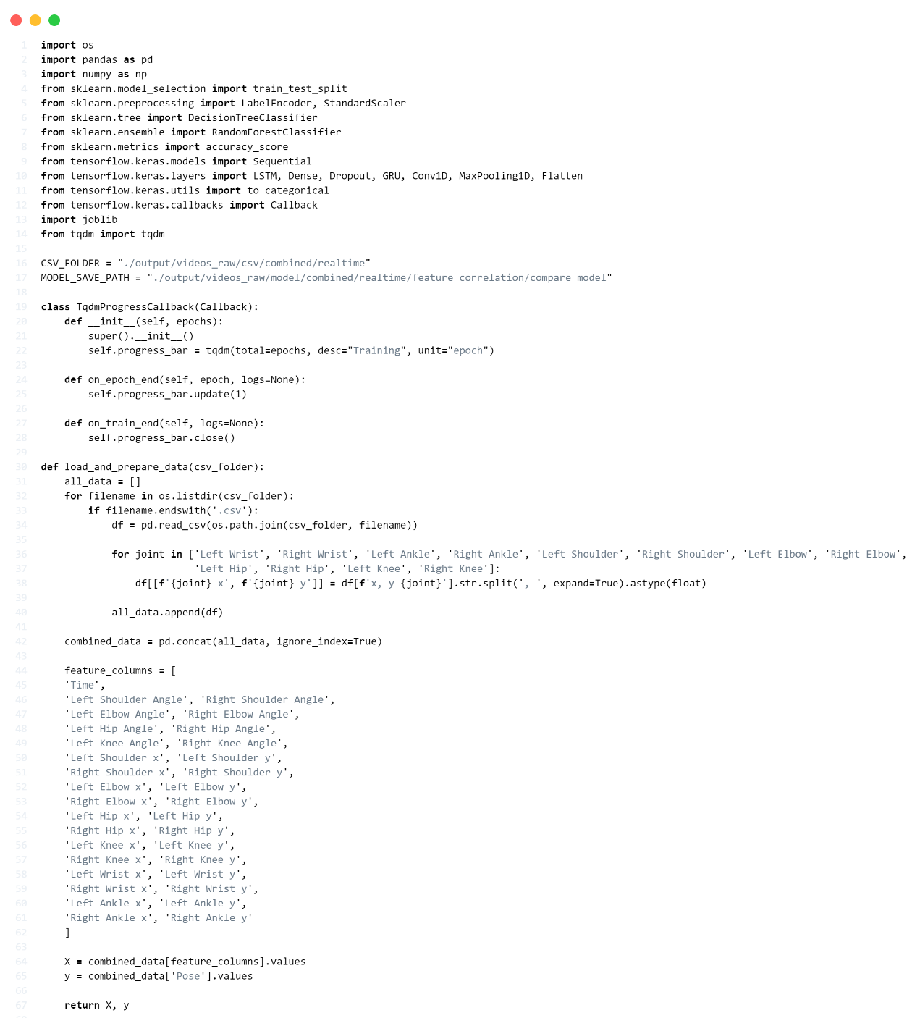
Figure 4-5 Train model

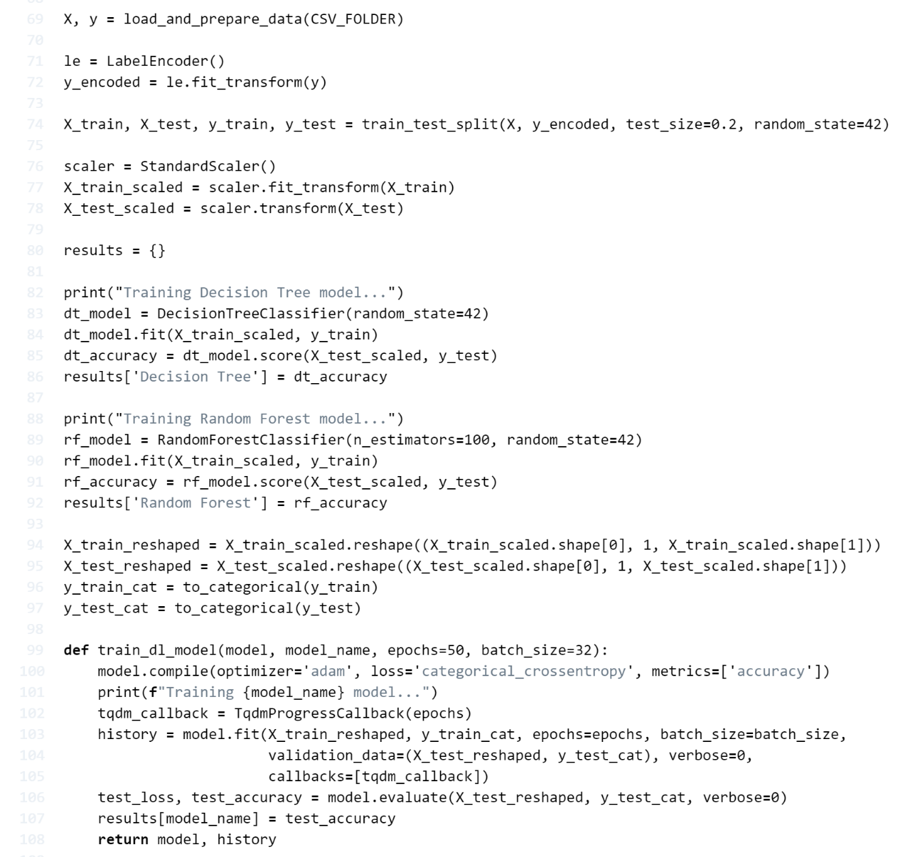
Figure 4-6 Train model (2)

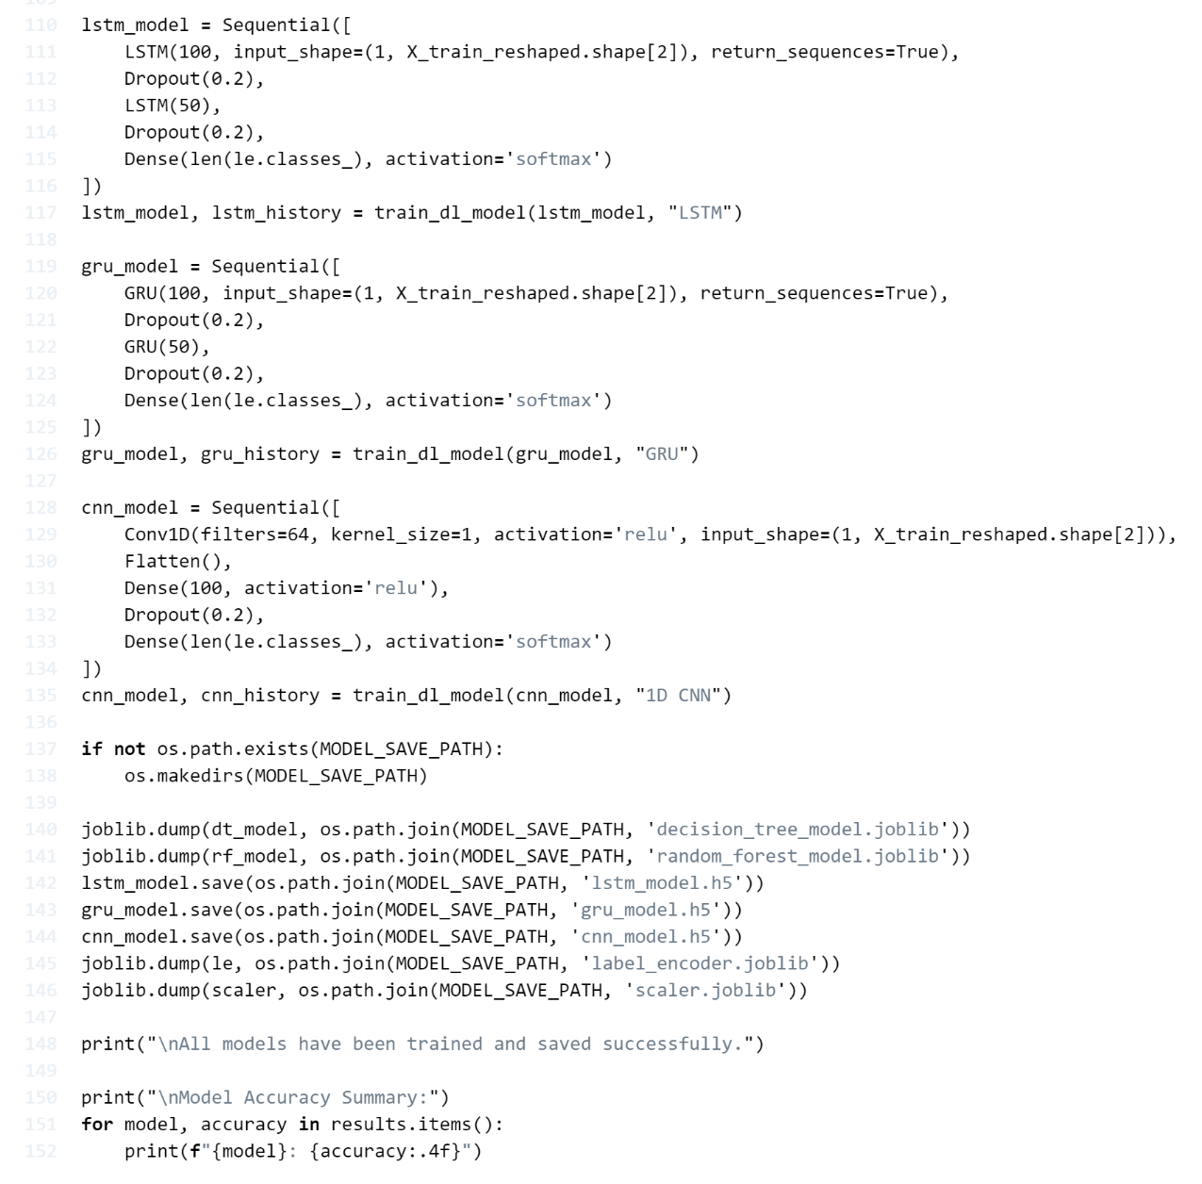
Figure 4-7 Train model (3)
Lines 1-15 Import necessary libraries and modules for data processing, machine learning, and deep learning tasks.
Lines 17-18 Define constants for input CSV folder and output model save path.
Lines 20-29 Define a custom Keras callback class 'TqdmProgressCallback' to display a progress bar during model training.
Lines 31-58 Define the 'load_and_prepare_data' function to:
- Read all CSV files in the specified folder.
- Process joint coordinates.
- Combine all data into a single DataFrame.
- Extract features and labels.
Line 60 Load and prepare data by calling the 'load_and_prepare_data' function.
Lines 62-63 Create a LabelEncoder and transform target labels into numerical format.
Line 65 Split the data into training and testing sets.
Lines 67-69 Initialize StandardScaler, fit it to the training data, and transform both training and testing data.
Line 71 Create an empty dictionary to store model results.
Lines 73-77 Train a Decision Tree model and store its accuracy.
Lines 79-83 Train a Random Forest model and store its accuracy.
Lines 85-88 Reshape the data for deep learning models and convert labels to categorical format.
Lines 90-99 Define the 'train_dl_model' function to compile, train, and evaluate deep learning models.
Lines 101-107 Create and train a LSTM model.
Lines 109-115 Create and train a GRU model.
Lines 117-135 Create and train a 1D CNN model.
Lines 137-138 Check if the model save directory exists, create it if it does not.
Lines 140-146 Save all trained models (Decision Tree, Random Forest, LSTM, GRU, CNN), LabelEncoder, and StandardScaler to files.
Line 148 Print a message confirming that all models have been trained and saved.
Line 150 Print a header for the model accuracy summary.
Lines 151-152 Iterate through the results dictionary and print the accuracy of each model.

4.3 Test model
4.3.1 Test model on Base-line data
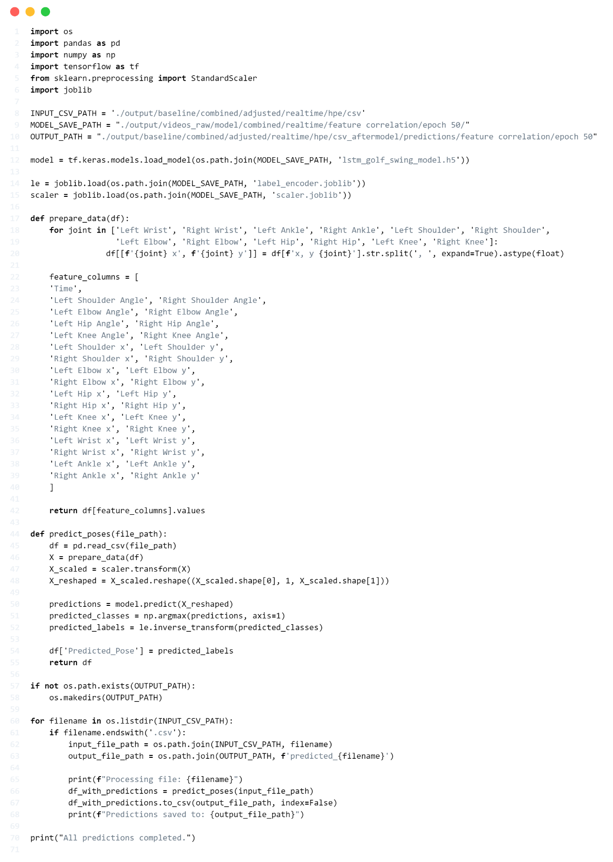
Figure 4-8 Test model on Base-line data
Line 1-5 These lines import necessary libraries: os, pandas, numpy, tensorflow, joblib and sklearn.
Line 8-10 Define file paths:
- INPUT_CSV_PATH: This is the path for the input CSV files containing golf swing data.
- MODEL_SAVE_PATH: This is the path for saving the trained LSTM model, label encoder, and scaler.
- OUTPUT_PATH: This is the destination folder for saving the CSV files after making predictions.
Line 12 Load the pre-trained LSTM model from the specified file (lstm_golf_swing_model.h5) located in MODEL_SAVE_PATH.
Line 14-15 Load the label encoder (le) and scaler (scaler) using joblib, which are used to map the predicted classes back to pose labels and scale the input features, respectively.
Line 17-20 This part defines the function prepare_data(df), which splits the combined x, y coordinates for various joints in the body as mentioned in Line 18 into separate x and y columns.
Line 22-40 This defines a list of feature columns, which includes time, joint angles, and joint x, y coordinates. These columns represent the features that the model uses for prediction.
Line 42 The function returns only the specified columns as a NumPy array, which used as input for the model.
Line 44-48 This defines the predict_poses(file_path) function:
- Read the CSV file into a DataFrame.
- Call prepare_data(df) to extract the relevant features.
- Scale the data using the pre-trained scaler.
- Reshape the data into the correct input shape for the LSTM model.
Line 50-52 The model makes predictions on the reshaped data:
- model.predict (X_reshaped) generates the raw predictions.
- np.argmax(predictions, axis=1) extracts the class with the highest probability for each prediction.
- le.inverse_transform(predicted_classes) converts the predicted class indices back into the original pose labels using the label encoder.
Line 54-55 Add a new column, Predicted_Pose, to the DataFrame containing the predicted pose labels, and returns the modified DataFrame.
Line 57-58 Check if the output directory exists; if not, it creates the directory to store the prediction results.
Line 60-63 Loop through all files in the input directory. For each CSV file, it constructs the input file path and defines the output file path for saving the predictions.
Line 65-68 For each CSV file:
- Logs the current file being processed.
- Calls predict_poses(input_file_path) to make predictions.
- Saves the modified DataFrame (with predictions) as a new CSV file in the output directory.
- Logs the location where the predictions were saved.
Line 70 After processing all files, log a message indicating that the prediction process is complete.

4.4 Evaluate process
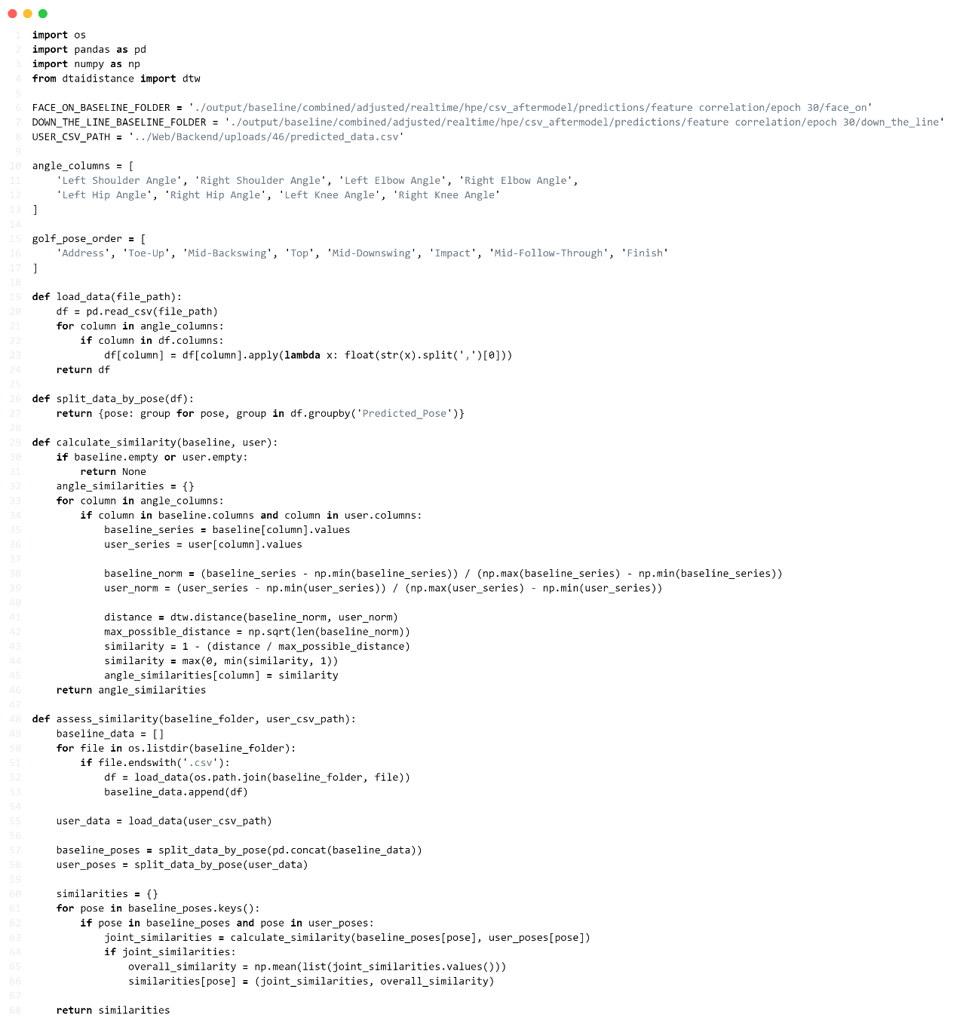
Figure 4-9 Evaluate process
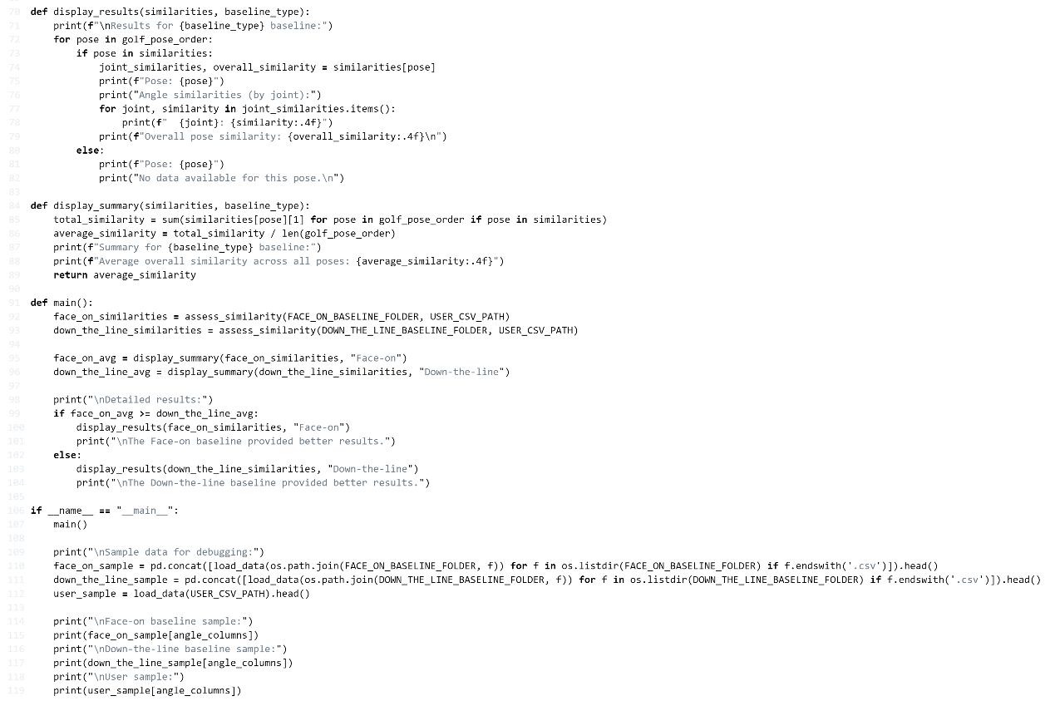
Figure 4-10 Evaluate process (2)
Lines 1-17 Library Imports and Initial Setup:
- Import necessary libraries: os, pandas, numpy, and dtw from dtaidistance
Define constants for file paths:
- FACE_ON_BASELINE_FOLDER: Path to face-on baseline data.
- DOWN_THE_LINE_BASELINE_FOLDER: Path to down-the-line baseline data.
- USER_CSV_PATH: Path to the user's CSV data file.
Define angle_columns:
- A list of angular features to be analyzed.
Define golf_pose_order:
- A list of golf swing poses in the correct sequence.
Lines 19-24 load_data Function:
- Read the CSV file using pandas.
- For each angle column: Convert the data to float, taking only the first value if comma separated.
- Returns: A pandas DataFrame with processed data.
Lines 26-27 split_data_by_pose Function:
- Use groupby to split the DataFrame by 'Predicted_Pose'.
- Returns: A dictionary with poses as keys and corresponding data as values.
Lines 29-46 calculate_similarity Function:
- Calculate similarity between baseline and user data for each angle.
- For each angle column:
  - Extract baseline and user data.
  - Normalize both datasets.
  - Calculate DTW distance between normalized datasets.
  - Convert distance to similarity score (0 to 1 range).
- Returns: A dictionary of similarity scores for each angle.
Lines 48-68 assess_similarity Function:
- Assess similarity between baseline and user data across all poses.
- Load all baseline CSV files and user CSV file.
- Split baseline and user data by pose.
- For each pose:
  - Calculate joint similarities using calculate_similarity.
  - Compute overall similarity for the pose.
  - Returns: A dictionary of similarities for each pose.
Lines 70-82 display_results Function:
- Print detailed similarity results.
- For each pose in golf_pose_order:
  - If pose data exists, print similarity scores for each joint and overall pose.
  - If there is no data, print "No data available".

Lines 84-89 display_summary Function:
- Calculate and display average similarity across all poses.
- Calculate total similarity across all poses.
- Compute and print average similarity.
- Returns: Average similarity score.
Lines 91-104 main Function:
- Orchestrate the entire analysis process.
- Assess similarities for both face-on and down-the-line baselines.
- Display summaries for both baseline types.
- Determine which baseline provided better results.
- Display detailed results for the better-performing baseline.
Lines 109-119 Debugging Section:
- Print sample data for debugging.
- Load and display sample data from face-on baseline, down-the-line baseline, and user data.

Chapter 5
Experiment
In this chapter, we delve into the fundamental components of our experiment. Specifically, we focus on the datasets that were employed for the purpose of the experiment.

5.1 Dataset
The GolfDB dataset serves as the primary source for this study, comprising a total of 1,400 video sequences of professional golfers performing swings. Each video captures key moments, including Address, Toe-Up, Mid-Backswing, Top, Mid-Downswing, Impact, Mid-Follow-Through, and Finish. The dataset is meticulously labelled with attributes such as the player's name, gender, type of club used, and camera angle. Additionally, it includes timestamps marking key events in each swing and bounding box coordinates to track the golfer's movements. A detailed overview of the videos included in the dataset shown in Table 5-1.
This study utilizes the GolfDB dataset, which features swings recorded from multiple camera angles specifically down-the-line and face-on. The videos are available in both real-time and slow-motion formats, enabling a comprehensive analysis of swings at varying speeds. The video clips are categorized based on their type (real-time or slow-motion) and further divided by camera angle (down-the-line, face-on, or other).

Video type | Down-the-line | Face-on | Other | Total
Real-time | 310 | 246 | 202 | 758
Slow-motion | 275 | 215 | 152 | 642
Total | 585 | 461 | 354 | 1,400
Table 5-1 Total videos in the dataset

5.1.1 Data Cleaning
In the analysis of golf swings, selecting the most appropriate camera angles is crucial for accurate data collection and interpretation. Given the wide variety of angles available, it was necessary to prioritize those that offered the clearest view of a golfer's mechanics.

The decision to prioritize these two angles was driven by two key factors:
5.1.1.1 The other camera angles in the dataset were too varied, making it difficult to extract consistent data for swing analysis. These angles often captured unconventional perspectives, adding noise and reducing the model’s ability to evaluate core swing mechanics.
5.1.1.2 Slow-motion clips were mostly derived from real-time videos that had been slowed down. Since the goal was to analyze the natural dynamics of a golfer’s swing, focusing on real-time footage was deemed more effective. Concentrating on down-the-line real-time and face-on real-time allowed the model to evaluate swings as they occurred naturally, without potential distortions from artificially slowed footage.

In summary, the primary focus was on down-the-line and face-on real-time clips, as indicated in Table 5-2, which shows that out of a total of 556 videos, 310 were down-the-line and 246 were face-on. These perspectives are critical for evaluating key aspects of a golfer’s swing, including body alignment and posture throughout the swing sequence.

Video type | Down-the-line | Face-on | Total
Real-time | 310 | 246 | 556
Table 5-2 Summary of videos used in the study

5.1.2 Data spilt
The dataset was divided into training and testing sets to ensure the model's robustness and accuracy. A ratio of 80:20 was applied, with 80% of the data (445 clips) allocated for training and 20% (111 clips) for testing. This split ensured equal representation of down-the-line and face-on real-time clips in both sets. Specifically, the training set consisted of 248 down-the-line clips and 197 face-on clips, while the testing set included 62 down-the-line clips and 49 face-on clips. These perspectives are critical for evaluating key aspects of a golfer's swing, including body alignment and posture throughout the swing sequence.

5.2 Training
5.2.1 Hardware and Software
The models are trained on a capable system powered by an AMD Ryzen 5 7520U CPU with Radeon Graphics and equipped with 16 GB of RAM. This setup provides a robust environment for processing the computational demands of model training.
To facilitate development, the project employs Visual Studio Code as the primary tool for program development and code writing. The programming is carried out in Python 3.10.11, ensuring compatibility with the various libraries utilized for deep learning tasks.
In addition, the project utilizes XAMPP Control Panel v3.3.0 for managing the MySQL database and the web server, creating a local environment for development and testing. The web framework is built with Vite React, providing a modern, efficient structure for the front-end. The back-end is powered by Node.js with Express, which serves as the foundation for the application’s server-side operations. Furthermore, the Python API leverages Flask, enabling seamless integration of Python functionalities into the overall architecture.
5.2.3 Training parameters
The training parameters focus on angle data derived from the x and y coordinates of key body joints. These angles are calculated using the formula outlined in Section 3.2.2.3 (referenced as formula 1), which tracks and analyzes the golfer's movements during the swing, facilitating the extraction of essential features necessary for pose classification.
Both machine learning and deep learning models were trained using their default parameters. The only hyperparameter manually controlled was the number of epochs, which was set to 30 across all models. This consistency ensured uniformity when comparing the model performances.
In addition, a 5-fold cross-validation approach was employed to ensure robustness and reliability. The dataset was split into five subsets, with each fold serving as a testing set once, while the remaining four folds were used for training. This method allowed the model to generalize better, as it was tested on unseen data across different folds, thereby reducing the risk of overfitting.
The features for training included time data and angle measurements calculated from various body joints, such as the shoulders, elbows, hips, and knees. By integrating both position and angle data, the model's ability to accurately recognize and analyze different golf swing poses was significantly enhanced.
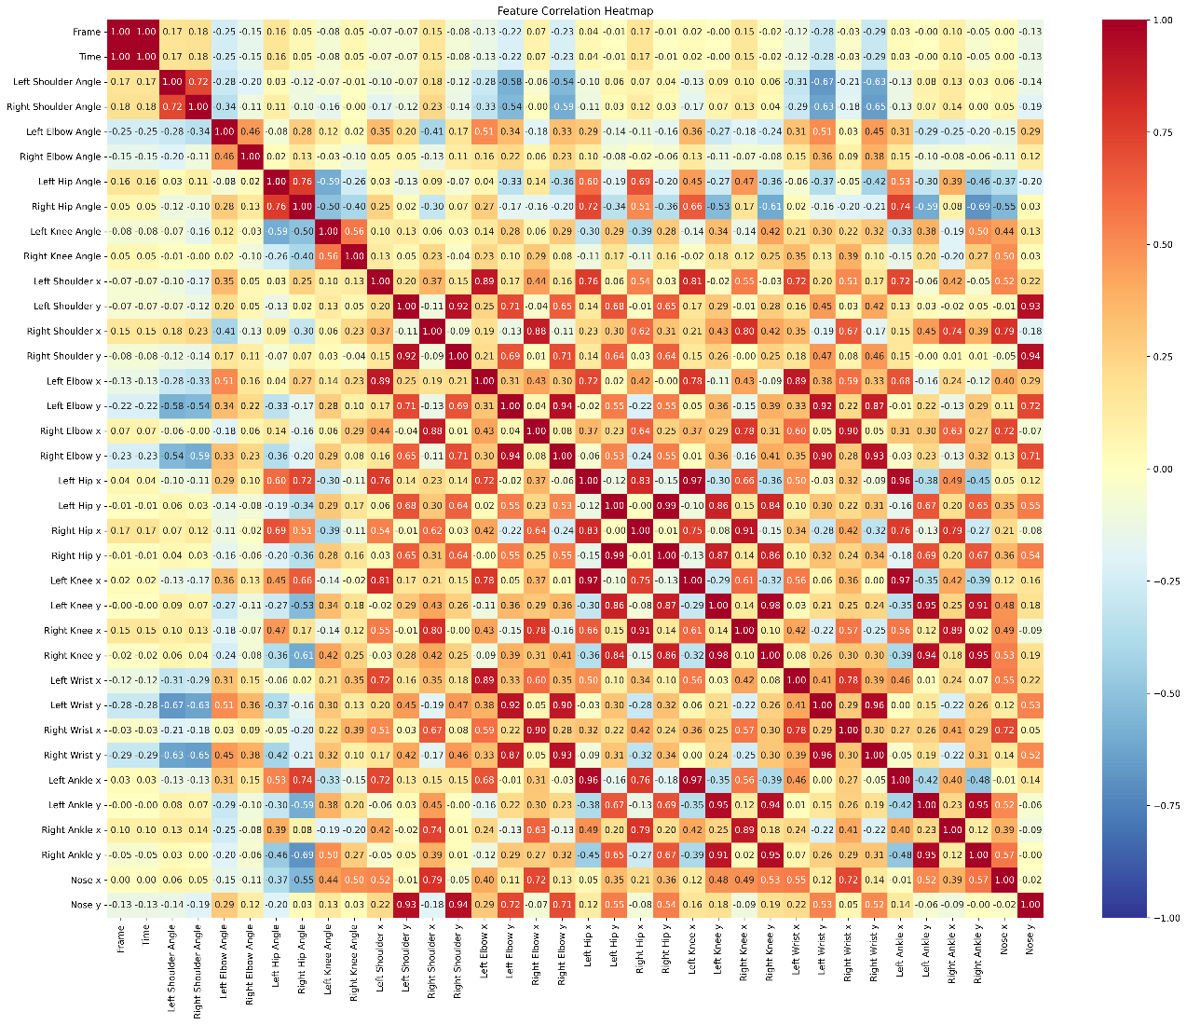
Figure 5-1 Features correlation

Before model training, these features underwent a feature correlation analysis, as shown in Figure 5-1. This process evaluated the degree of correlation between each feature, ensuring that all features contributed valuable and complementary information to the model. The analysis confirmed that all features displayed significant correlations, meaning that the following features had significant correlations for classifying the pose and were mainly focused on for the scoring system.
The specific features employed for model training are as follows:
- Time: The duration for which each frame is recorded in the video.
- Left Shoulder Angle and Right Shoulder Angle: The angles formed by the left and right shoulders are critical for assessing body posture.
- Left Elbow Angle and Right Elbow Angle: The angles at the left and right elbows indicate arm extension and flexion during the swing.
- Left Hip Angle and Right Hip Angle: The angles at the left and right hips are essential for in hip rotation during the swing.
- Left Knee Angle and Right Knee Angle: The angles at the left and right knees reflect leg bending or straightening throughout the swing.
- Left Shoulder x and y, Right Shoulder x and y: The x and y coordinates of the left and right shoulder joints
- Left Elbow x and y, Right Elbow x and y: The x and y coordinates of the left and right elbow joints
- Left Hip x and y, Right Hip x and y: The x and y coordinates of the left and right hip joints
- Left Knee x and y, Right Knee x and y: The x and y coordinates of the left and right knee joints
- Left Wrist x and y, Right Wrist x and y: The x and y coordinates of the left and right wrist joints
- Left Ankle x and y, Right Ankle x and y: The x and y coordinates of the left and right ankle joints

5.3 Evaluation Metrics
To evaluate the performance of the golf swing pose classification model, eight key metrics were employed to assess its effectiveness in predicting specific golf swing poses. These poses including Address, Toe-Up, Mid-Backswing, Top, Mid-Downswing, Impact, Mid-Follow-Through, and Finish. The selected evaluation metrics after a comprehensive understanding of the model's performance in accurately identifying each pose. The following are the primary metrics used for this evaluation:
- Accuracy: Accuracy represents the proportion of instances the model correctly predicted out of the entire dataset. It serves as a fundamental metric for classification and offers a general overview of the model's overall performance. However, accuracy can be misleading, especially if classes are imbalanced.
- Precision: Precision evaluates the correctness of the positive predictions. It is the ratio of true positive predictions to the sum of true positives and false positives. High precision indicates that the false positive rate is low, meaning that when the model predicts a positive label, it is usually correct.
- Recall (Sensitivity): Recall gauges the model's ability to identify all relevant instances. It is the ratio of true positive predictions to the sum of true positives and false negatives. High recall means that the model successfully captured most of the positive cases.
- F1 Score: The F1 score is a single metric that combines both precision and recall, providing a balanced measure of the model's accuracy. It is particularly useful when classes are imbalanced and offers a more holistic view of model performance than accuracy.
- Receiver Operating Characteristic (ROC) Curve: The ROC curve plots the true positive rate (recall) against the false positive rate at various classification thresholds. The area under the ROC curve (AUC) quantifies the model's ability to distinguish between the classes. An AUC of 1 indicates perfect classification, while an AUC of 0.5 suggests that the model's predictions are no better than random guessing.

5.4 Results and Discussion
This section presents a comprehensive analysis of the experimental results, focusing on the performance of various machine learning and deep learning models in classifying golf swing poses from real-time video clips. The dataset used consists solely of real-time footage, combining both face-on and down-the-line camera angles. By evaluating models under these conditions, the aim is to assess their effectiveness in identifying specific golf swing poses.
The analysis explores the effectiveness of each model in handling real-time video data and its ability to generalize across varying camera perspectives. Accuracy, precision, recall, and F1 score are evaluated to offer insights into the strengths and weaknesses of each model. Comparisons between the machine learning and deep learning approaches highlight their suitability for accurately evaluating golf swings, with a particular focus on real-time video conditions.
Several experiments were conducted to train the models using various datasets and feature sets to evaluate their performance in classifying golf swing poses. These experiments were designed to explore different configurations and select the most effective approach for golf swing analysis. The following configurations were tested:
- Training with Real-time and Slow-Motion Data Without Angular Features:
In the initial experiment, the models were trained using both real-time and slow-motion video clips, but without incorporating angular features. Instead, the models were fed positional data of key joints (e.g., wrists, elbows, shoulders) without considering angular calculations. This approach allowed the models to infer swing patterns based on overall body movements but may have lacked the precision offered by angular measurements. The results from this experiment are presented in Table 5-3.

Model | Accuracy | Precision | Recall | F1 | ROC
Decision Tree | 0.9136 | 0.9132 | 0.9136 | 0.9134 | 0.9490
Random Forest | 0.9637 | 0.9635 | 0.9637 | 0.9635 | 0.9786
LSTM | 0.9038 | 0.9039 | 0.9038 | 0.9018 | 0.9394
GRU | 0.8992 | 0.8993 | 0.8992 | 0.8972 | 0.9370
1D CNN | 0.7289 | 0.7208 | 0.7289 | 0.7097 | 0.8262
Table 5-3 Model Evaluation Metrics (Real-time & Slow-Motion Data without Angular Features)

- Training with Real-time and Slow-Motion Data Using Angular Features:
In the second experiment, the models were trained using both real-time and slow-motion video clips. For each frame, angular features, such as shoulder, elbow, hip, and knee angles, were calculated and used as input features. These angular measurements help the model assess critical aspects of the golfer's posture and movement throughout the swing. By analyzing the changes in these angles over time, the model could evaluate the correctness of each swing position based on reference data. The results from this experiment are presented in Table 5-4.

Model | Accuracy | Precision | Recall | F1 | ROC
Decision Tree | 0.9232 | 0.9227 | 0.9232 | 0.9229 | 0.9553
Random Forest | 0.9659 | 0.9657 | 0.9659 | 0.9657 | 0.9802
LSTM | 0.8983 | 0.8986 | 0.8983 | 0.8960 | 0.9357
GRU | 0.8925 | 0.8933 | 0.8925 | 0.8896 | 0.9314
1D CNN | 0.7204 | 0.7111 | 0.7204 | 0.6930 | 0.8181
Table 5-4 Model Evaluation Metrics (Real-time & Slow-Motion Data with Angular Features)

- Training with Real-time Data Without Angular Features:
The third experiment focused solely on real-time video data without using slow-motion clips or angular features. In this configuration, the models were trained using only the positional data of key joints from real-time videos. The emphasis was on analyzing natural, real-time movements, making this approach suitable for real-world scenarios where the speed and sequence of actions are crucial. This setting allowed the model to learn from real-time dynamics but did not include angle-specific information. The results from this experiment are presented in Table 5-5.

Model | Accuracy | Precision | Recall | F1 | ROC
Decision Tree | 0.9214 | 0.9196 | 0.9214 | 0.9203 | 0.9492
Random Forest | 0.9568 | 0.9560 | 0.9568 | 0.9550 | 0.9702
LSTM | 0.9281 | 0.9265 | 0.9281 | 0.9228 | 0.9417
GRU | 0.9254 | 0.9237 | 0.9254 | 0.9198 | 0.9398
1D CNN | 0.8249 | 0.8008 | 0.8249 | 0.7889 | 0.8505
Table 5-5 Model Evaluation Metrics (Real-time Data without Angular Features)

- Training with Real-Time Data Using Angular Features:
In the final experiment, the models were trained exclusively on real-time video data, incorporating angular features such as joint angles in the training process. This approach aimed to combine the advantages of real-time data with the precision provided by angular measurements. The angular features helped the models focus on key aspects of body alignment and posture, enhancing the model's ability to detect subtle differences in the golfer’s movements and improving accuracy in pose classification. The results from this experiment are presented in Table 5-6.

Model | Accuracy | Precision | Recall | F1 | ROC
Decision Tree | 0.9131 | 0.9116 | 0.9131 | 0.9122 | 0.9416
Random Forest | 0.9551 | 0.9542 | 0.9551 | 0.9537 | 0.9677
LSTM | 0.9309 | 0.9293 | 0.9309 | 0.9262 | 0.9443
GRU | 0.9304 | 0.9288 | 0.9304 | 0.9260 | 0.9445
1D CNN | 0.8288 | 0.8099 | 0.8288 | 0.8003 | 0.8539
Table 5-6 Model Evaluation Metrics (Real-time Data with Angular Features)

The decision to conduct the experiment on Training with Real-time Data Using Angular Features was based on the objective of integrating the advantages of real-time video data with the precision afforded by angular measurements. This combination is critical for accurately assessing the golfer's posture and movement throughout the swing, thereby enhancing the model's overall performance in pose classification. The results indicated in Table 5-6 demonstrate that this configuration outperforms the other training approaches, achieving overall higher accuracy, precision, recall, and F1 scores across the models, thus validating the effectiveness of utilizing angular features in the analysis of golf swing poses.

To provide a more in-depth analysis of each model's performance based on the results in Table 5-6, the following sections examine their strengths, limitations, and key characteristics:
The Decision Tree model exhibited an accuracy of 0.9131, with high scores in both precision (0.9116) and recall (0.9131). The model’s F1 score (0.9122) indicates a good balance between precision and recall, making it a well-rounded classifier for this task. As illustrated in Figure 5-2, the confusion matrix further highlights the model’s ability to correctly classify most instances, though some misclassifications still occur. While the ROC score of 0.9416 is strong, it suggests that the Decision Tree may not handle the complexity of the data as effectively as more advanced models, including Random Forest. Despite its simplicity, the Decision Tree offers the advantage of interpretability, allowing for easier visualization and understanding of the classification rules. However, its limitation lies in potential overfitting to the training data, as it tends to form highly specific decision boundaries that may not generalize well to unseen data.

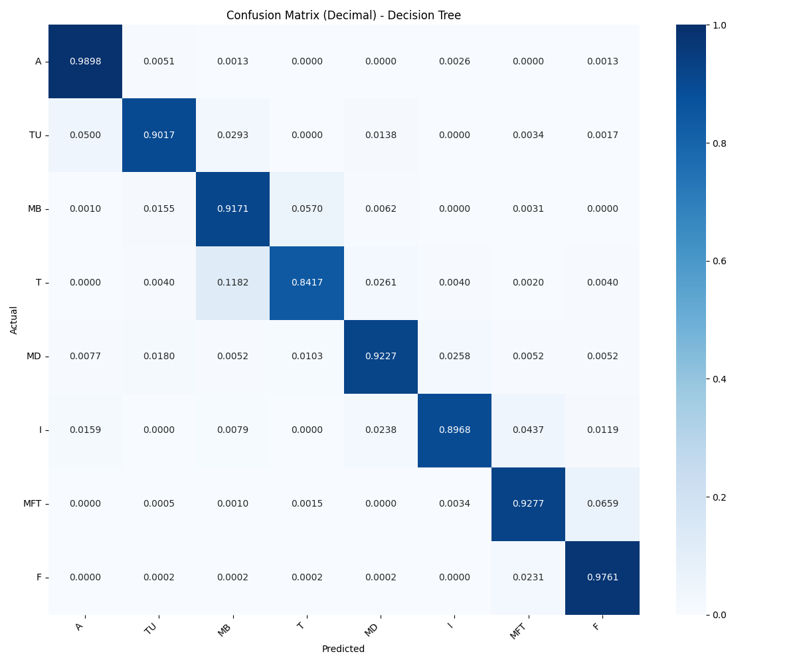
Figure 5-2 Confusion matrix of Decision Tree

The Random Forest model demonstrated superior performance with the highest accuracy (0.9551) and the best ROC score (0.9677) among all the models. This model excels due to its ensemble nature, which aggregates the results from multiple decision trees, mitigating the overfitting problem observed in single decision trees. As illustrated in Figure 5-3, the confusion matrix shows that Random Forest consistently achieves high classification accuracy, with very few misclassified instances. The high precision (0.9542) and recall (0.9551) scores show that Random Forest is both accurate in identifying positive instances and robust in capturing all relevant cases. The F1 score of 0.9537 reflects this balance, indicating that the model performs exceptionally well in both precision and recall metrics. The high ROC score further solidifies Random Forest's ability to distinguish between different golf swing poses across the dataset, making it a strong candidate for this classification task. However, it should be noted that Random Forest is computationally more demanding due to the ensemble of trees, which may lead to longer training times, particularly when dealing with large datasets.
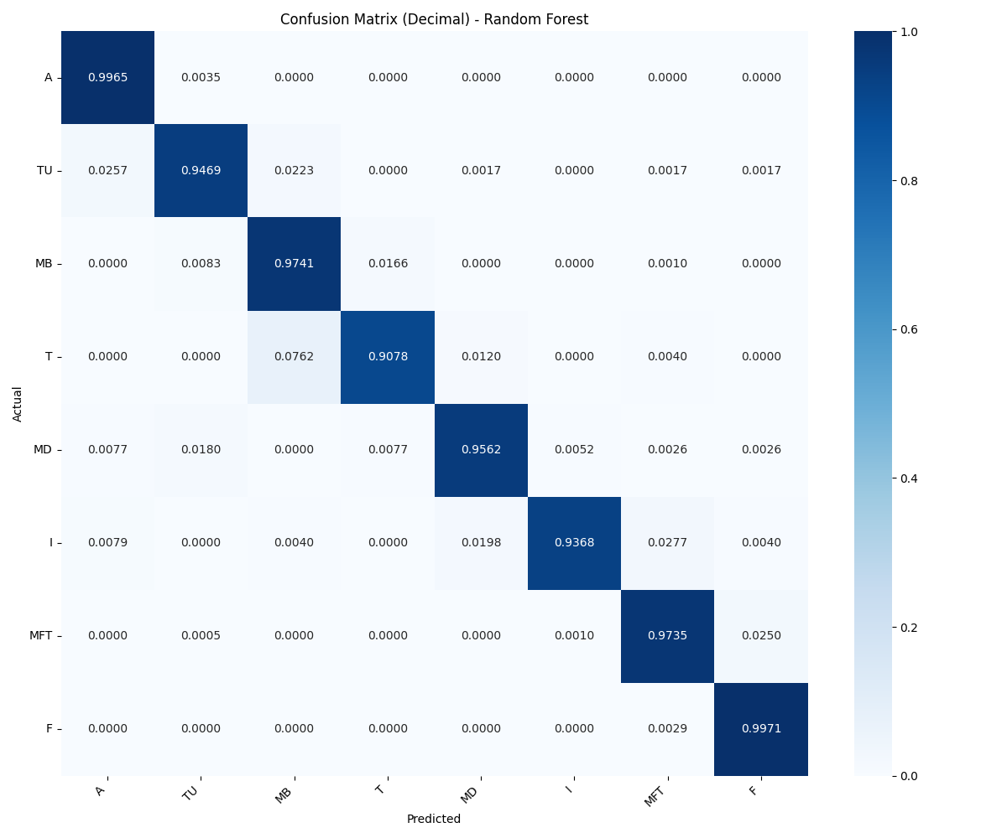
Figure 5-3 Confusion matrix of Random Forest

The Long Short-Term Memory (LSTM) model, which is designed to capture temporal dependencies in sequential data, achieved an accuracy of 0.9309 and a precision of 0.9293. The recall score of 0.9309 indicates its ability to correctly classify most of the golf swing poses. As illustrated in Figure 5-4, the confusion matrix highlights the model's effectiveness in distinguishing between the various poses, though some misclassifications persist. This makes LSTM particularly suitable for video data where understanding the sequence of movements is crucial. The F1 score of 0.9262 and the ROC score of 0.9443 further emphasize its ability to balance precision and recall effectively. LSTM’s strength lies in its ability to retain important temporal information from the input data, which is essential for real-time pose estimation. However, this model may require more tuning and resources (e.g., GPU processing) to optimize its performance fully, as training times can be significantly longer due to the complexity of recurrent layers.
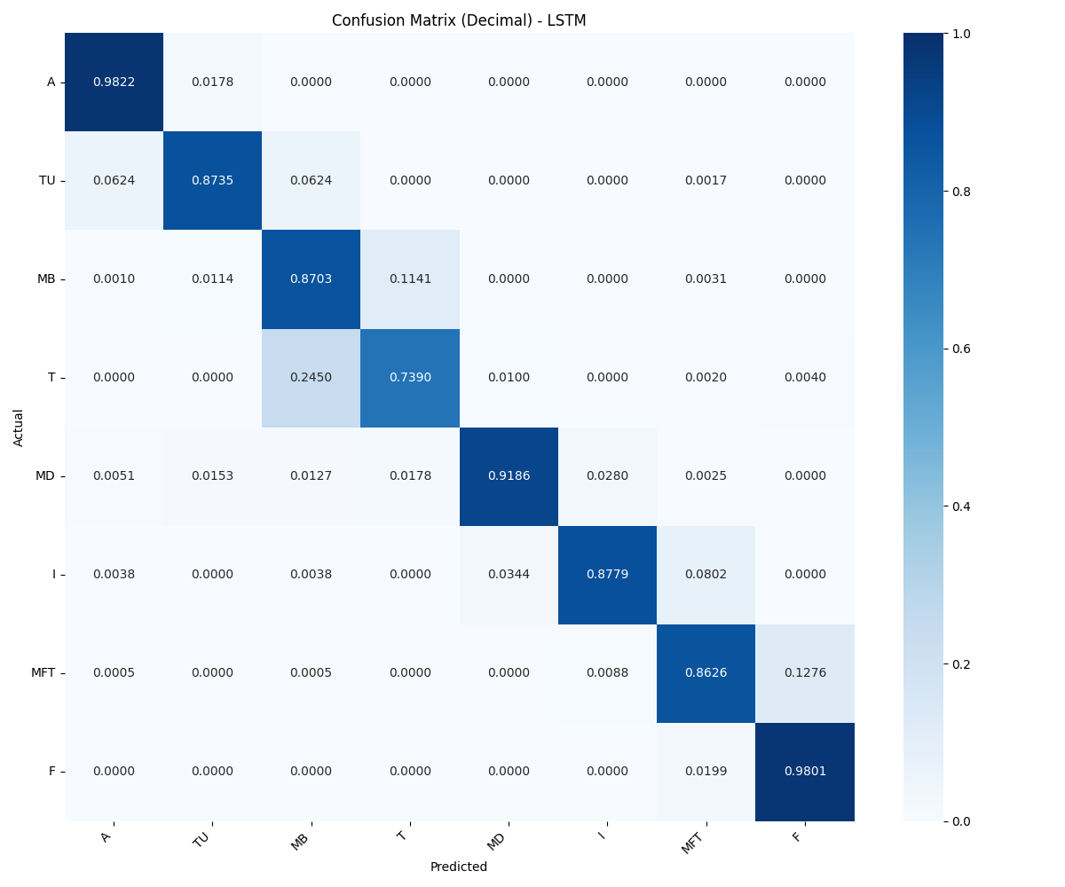
Figure 5-4 Confusion matrix of LSTM

The Gated Recurrent Unit (GRU) model is well-suited for handling sequential data, similar to Long Short-Term Memory (LSTM) networks. Its accuracy (0.9304) and precision (0.9288) are comparable to those of LSTM. As illustrated in Figure 5-5, the confusion matrix demonstrates the GRU model’s ability to classify golf swing poses effectively, although a few misclassifications remain. Its recall score of 0.9304 and an F1 score of 0.9260 indicate that it performs similarly in balancing the identification of true positives and reducing false negatives. GRU models typically have fewer parameters than LSTM, resulting in greater computational efficiency without sacrificing much accuracy, as evidenced by the ROC score of 0.9445. The primary advantage of GRU over LSTM is its reduced complexity, leading to faster training times, which may make it a preferable choice in real-time applications or when resources are limited. However, GRU may struggle with longer sequences where LSTM could better retain information from earlier time steps.
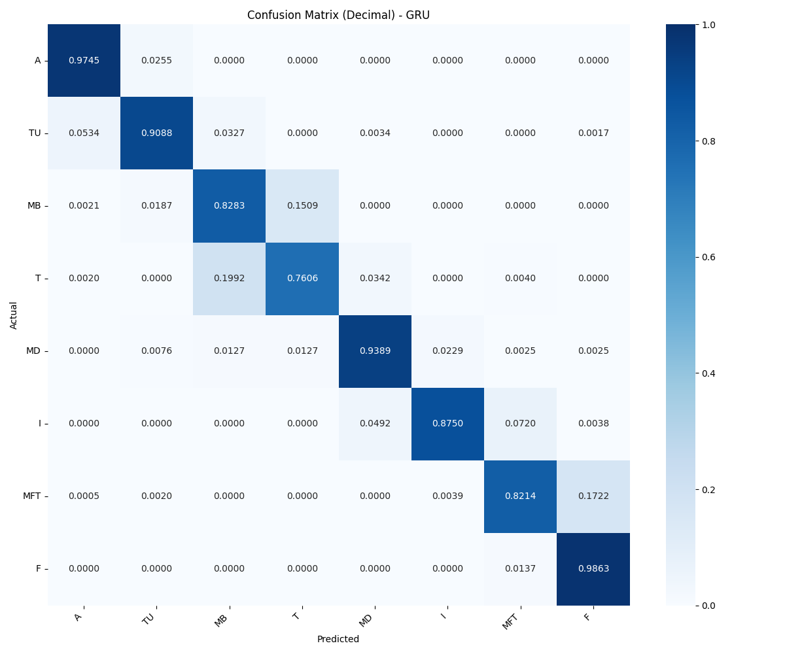
Figure 5-5 Confusion matrix of GRU

The One-Dimensional Convolutional Neural Network (1D CNN) model demonstrated the lowest performance among the tested models, achieving an accuracy of 0.8288 and a precision score of 0.8099. As illustrated in Figure 5-6, the confusion matrix highlights the model's struggle with correctly classifying many instances, resulting in noticeable misclassifications. The recall score of 0.8288 and the F1 score of 0.8003 indicate that the model had difficulty balancing precision and recall. The ROC score of 0.8539 further highlights its relatively weaker ability to distinguish between different golf swing poses. While 1D CNNs are commonly used for time-series data and can capture local patterns, their performance in this context suggests that the model may not be as effective in addressing the complex, global dependencies present in video-based pose estimation. The model's limitations could stem from the inherent difficulty of applying convolutional layers to sequential data, where temporal relationships are more important than spatial features. As a result, the 1D CNN might not fully capture the intricacies of pose classification, especially in comparison to LSTM or GRU models, which are better equipped for handling sequential data.
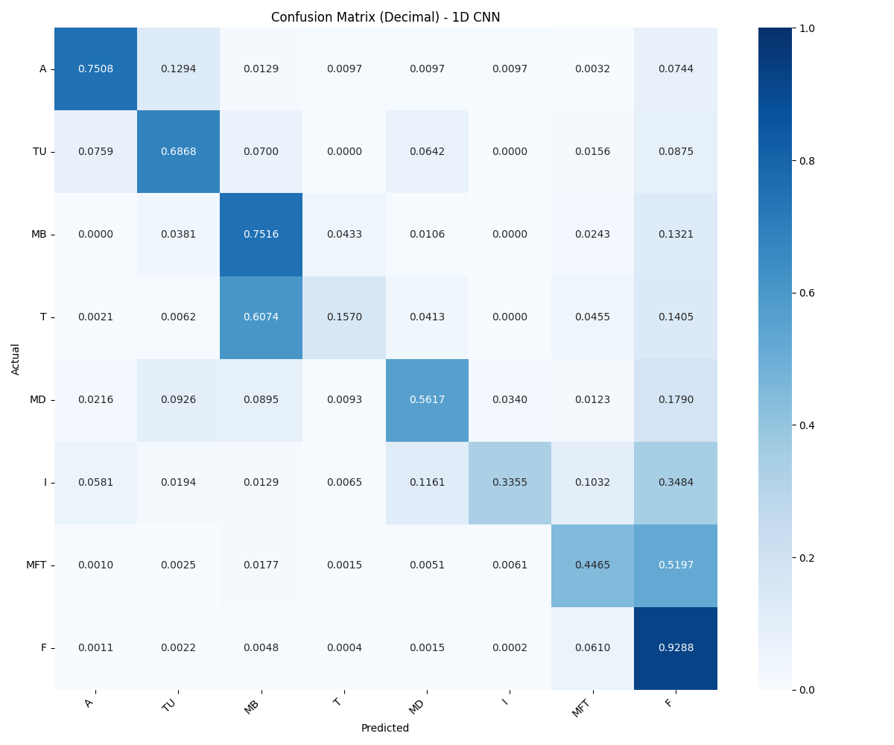
Figure 5-6 Confusion matrix of 1D CNN
Although Random Forest achieved the highest accuracy in the 5-fold cross-validation process, with a score of 0.9551 and the best ROC score of 0.9677, its performance on real-time data revealed a key limitation. The model was unable to predict golf swing poses in the correct sequence. This limitation arises from the nature of Random Forest, which lacks the ability to learn sequential data. As an ensemble of decision trees, it classifies each instance independently, without considering the order of the data points. Consequently, while the predicted poses might be accurate, they do not reflect the correct order of a golfer’s swing movement.
In contrast, the LSTM model, which scored a slightly lower accuracy of 0.9309, has the advantage of handling sequential data effectively. This makes it more suitable for analyzing golf swings, where the sequence of movements is crucial. The LSTM model's ability to retain information over time allows it to capture the progression of poses, making it a better choice for tasks that involve continuous movements. However, LSTM models tend to require more computational resources and training time compared to Random Forest, but their superior performance in handling time-series data makes them valuable in applications where maintaining the correct sequence is critical.
As demonstrated in Table 5-7 and Table 5-8, the difference in sequence prediction capabilities between Random Forest and LSTM models is evident. Table 5-7 shows that the Random Forest model, despite its high accuracy, predicts poses in a seemingly random order, jumping from "Impact" to "Address" and then to "Mid-Downswing" and "Toe-Up". In contrast, Table 5-8 illustrates that the LSTM model predicts poses in a more logical and sequential manner, progressing from "Address" to "Toe-Up" and then to "Mid-Backswing", which aligns more closely with the natural progression of a golf swing.

TIME | PREDICTED_POSE (Random Forest) | PREDICTED_POSE (LSTM)
3.870537 | Impact | Address
3.903904 | Impact | Address
3.937271 | Impact | Address
3.970637 | Impact | Address
4.004004 | Impact | Address
4.037371 | Address | Toe-Up
4.070737 | Address | Toe-Up
4.104104 | Address | Toe-Up
4.137471 | Mid-Downswing | Toe-Up
4.170838 | Toe-Up | Toe-Up
4.204204 | Toe-Up | Toe-Up
4.237571 | Mid-Downswing | Mid-Backswing
4.270938 | Mid-Downswing | Mid-Backswing
Table 5-7 Sample Predictions from Random Forest Model and LSTM Model

In summary, while Random Forest delivered the best results in terms of overall accuracy and classification performance on the test data, it struggled with real-time sequence prediction due to its inability to learn temporal relationships, as evidenced by the erratic pose predictions in Table 5-7. On the other hand, the LSTM model, despite having slightly lower accuracy, showed greater potential for tasks involving continuous sequences of movements, such as golf swing analysis, by maintaining a more coherent and realistic sequence of poses. This difference in model capabilities highlights the importance of choosing models that align with the specific characteristics of the data and the nature of the problem being addressed, particularly in applications where the correct sequence of events is crucial.

5.5 Evaluation for web application
In this section, the focus is on creating a baseline dataset of professional golfers
that serves as a standard for comparison when scoring user data. The initial process involves utilizing a dataset consisting of real-time video clips captured from both down-the-line and face-on angles, as detailed in Table 5-2. This dataset includes various attributes such as the player's name, gender, type of club used, and camera angle. Additionally, it contains timestamps marking key events during each swing and bounding box coordinates to track the golfer's movements.
Next, the average time across the dataset is calculated to establish a standard duration, addressing the issue of variability in swing durations. After calculations, the standard time determined is approximately 8.76 seconds. Following this, all clips in the dataset are adjusted to ensure they have a consistent length.
Subsequently, the adjusted clips are processed using HPE through MediaPipe, which extracts the x and y coordinates of body points. From these coordinates, the angular measurements are calculated to further enhance the dataset. The processed data is then used to predict the eight specific golf swing poses using an LSTM model.
After obtaining the predictions, a comprehensive cleaning process is employed to refine the results. Initially, the predicted poses are converted into numerical representations based on a predefined correct sequence, which includes poses such as Preparation, Address, Toe-Up, Mid-Backswing, Top, Mid-Downswing, Impact, Mid-Follow-Through, and Finish.
To reduce noise and smooth the sequence, a custom median filter is applied. This filter examines a specified window of data around each pose, typically including a few preceding and following poses (e.g., 3 before and 3 after). The pose at each point is then replaced with the median value from this window, ensuring that outliers and short-term fluctuations are minimized.
Continuity checks are also performed to prevent excessive changes between consecutive poses. If a pose changes too drastically from one step to the next (e.g., skipping more than one position in the correct sequence), the previous pose is retained to maintain stability.
Any missing poses from the correct sequence are also inserted back into the predictions, ensuring a comprehensive representation of all key poses. Finally, the length of the cleaned predictions is adjusted to match the original dataset, ensuring consistency. This cleaning process significantly enhances the reliability of the data and improves the accuracy of golf swing evaluations.
When a user uploads a video clip to the system, it initiates a streamlined process designed to ensure consistency and accuracy in scoring. The uploaded clip is first adjusted to meet the established standard duration of approximately 8.76 seconds, which allows for a fair comparison with the baseline dataset.
Following the adjustment, the clip undergoes HPE using MediaPipe to extract the x and y coordinates of key body points. These coordinates are then used to predict the eight specific golf swing poses.
Once predictions are generated, the same cleaning procedure applied to the baseline dataset is employed to refine the results. This includes converting predicted poses to numerical representations, applying a custom median filter to reduce noise, and ensuring continuity among the poses.
The cleaned data is then compared to the baseline dataset captured from both down-the-line and face-on angles. The system calculates the Euclidean distance between the user’s angular measurements for each swing pose and those in the baseline data. These distances are transformed into similarity scores expressed as percentages, giving users an intuitive understanding of their swings about established standards.
The system evaluates performance metrics from both down-the-line and face-on camera angles. It then determines which perspective yields better results for the user's swing analysis. The angle demonstrating the highest similarity scores is identified and communicated to the user. This step ensures that the analysis aligns with the optimal viewing angle for the user's swing. By focusing on the most effective camera angle, the system enhances the reliability of its results. Users receive feedback tailored specifically to their performance under the best conditions. This approach provides actionable and relevant insights, significantly contributing to the user's training and improvement in golf swing mechanics.

5.6 Web Application Overview
In this section, the focus is on providing an overview of the web application, detailing the various pages and their functionalities.
- Homepage: When users first visit the homepage, they are greeted with a brief overview of the project. This includes a concise introduction explaining the purpose of the application and its role in analyzing and improving golf swings, as well as the objective of the system. These sections help users understand the functionality of the platform. If the user has not logged in, a Login button is displayed in the top-right corner, as shown in Figure 5-7, Figure 5-8 and Figure 5-9. Users who do not have an account can create one by signing up through the Sign-Up option, as shown in Figure 5-10. If users already have an account, they can go directly to the Login page, as shown in Figure 5-11. Once logged in, this button changes to a Logout button, and a navigation menu appears, allowing users to access additional features. The menu provides links to the History page, where users can review their previous analyses, and the Upload Clip page, where they can submit new video for evaluation, as shown in
Figure 5-12.

Figure 5-7 Homepage Before Login

Figure 5-8 Homepage Before Login (2)


Figure 5-9 Homepage Before Login (3)


Figure 5-10 Sign Up Page


Figure 5-11 Login Page

Figure 5-12 Homepage After Login

- Video Upload Page: The Video Upload Page allows users to upload their golf swing videos for evaluation and scoring. Once the user uploads their clip, the system processes the video to analyze each swing pose, as shown in Figure 5-13 and Figure 5-14. After the analysis is complete, the results are displayed, showing the score for each individual pose. Additionally, detailed scores for each angle within every pose are provided, giving the user a comprehensive view of their performance. The final section presents the overall average score for the entire swing session, as shown in Figure 5-15 and Figure 5-16.
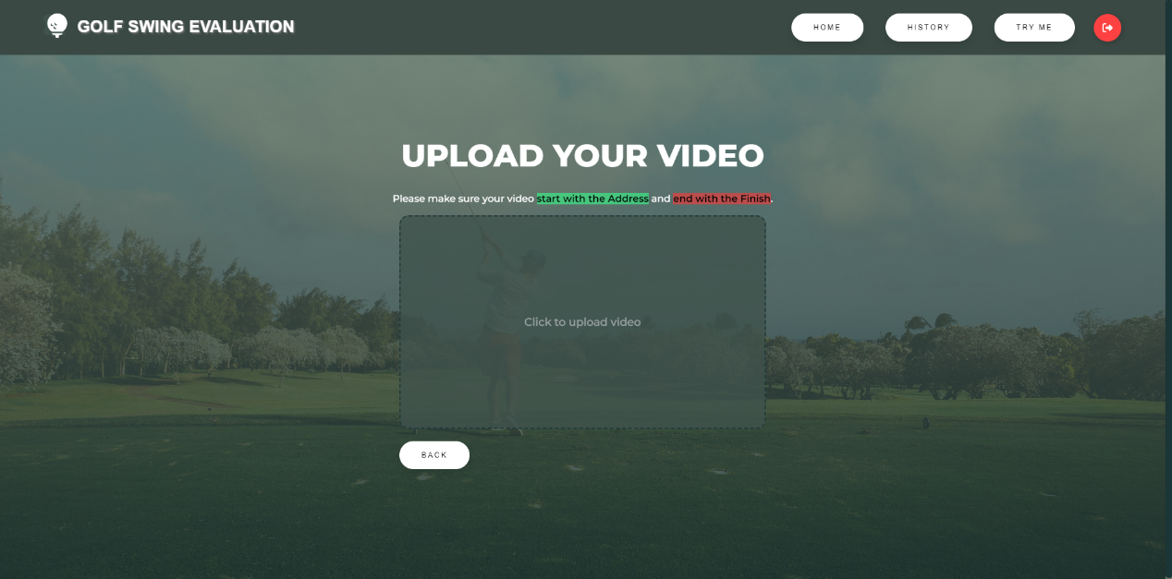
Figure 5-13 Video Upload Page

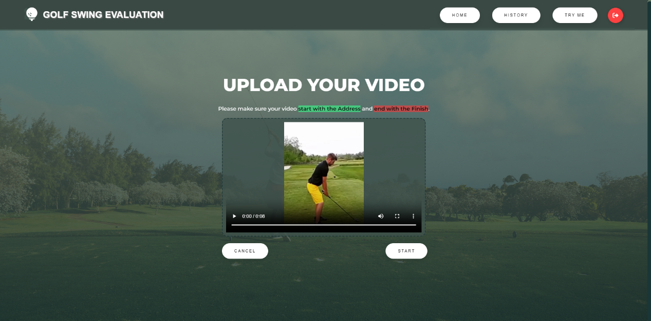
Figure 5-14 Video Upload Page (2)

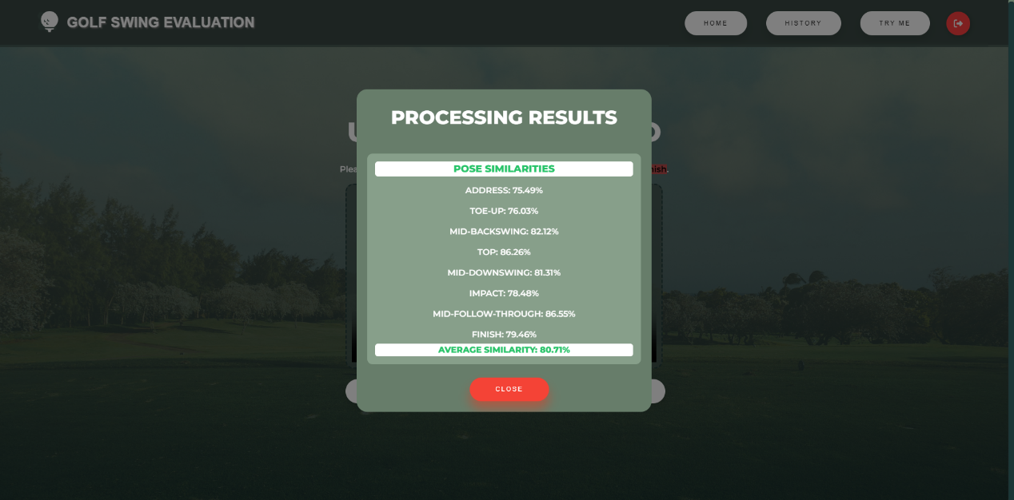
Figure 5-15 Video Upload Page (3)

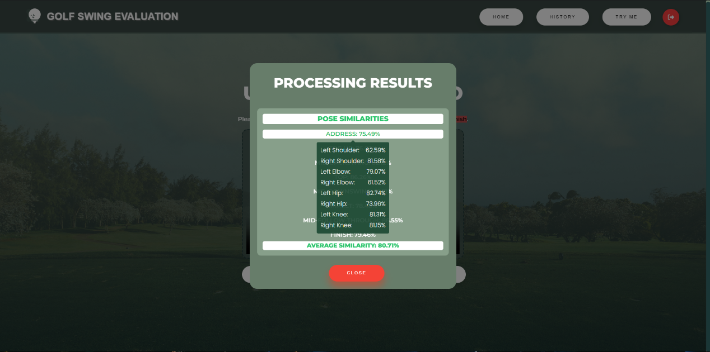
Figure 5-16 Video Upload Page (4)

- History Page: The History Page displays a summary of the user's past results, providing a comprehensive overview of their golf swing analyses. It shows the date and time when the user performed each analysis, along with the input clip they submitted, as shown in Figure 5-17. Additionally, for each pose in the swing, the page presents a breakdown of scores, with detailed scores for various angles displayed. The final section of the page showcases the average score for the entire swing session, giving the user an overall performance evaluation, as shown in Figure 5-18.

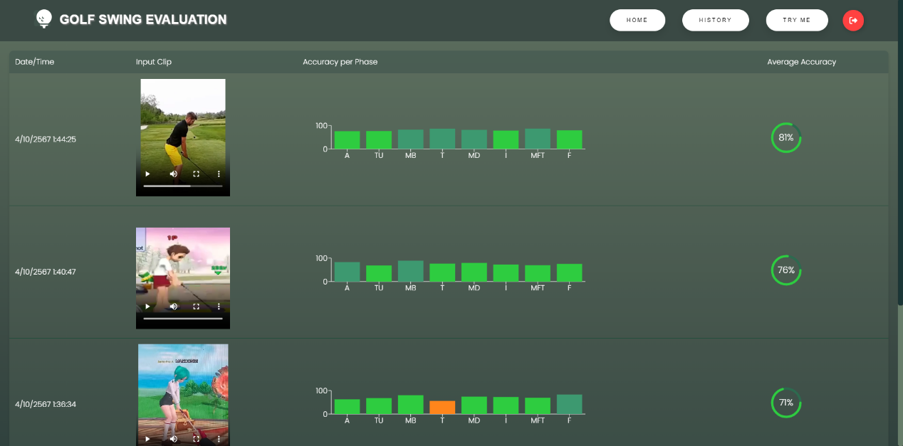
Figure 5-17 History Page

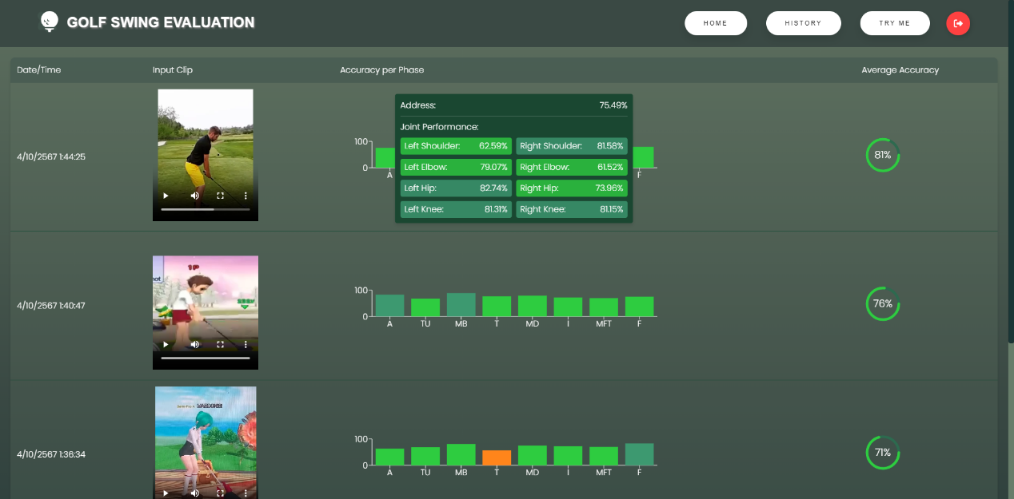
Figure 5-18 History Page (2)

Chapter 6
Conclusion
This research aimed to develop a comprehensive golf swing analysis system using machine learning and deep learning models. The primary objectives were twofold: first, to accurately classify golf swing poses from real-time video data, and second, to provide meaningful feedback to users by comparing their swings against a baseline dataset of professional golfers.

In this chapter, the presentation includes significant findings from model evaluations, the development of a baseline dataset for comparison, encountered challenges, solutions, and the implementation of these components into a user-friendly web application for golf swing analysis and improvement.

6.1 Main Finding
In the evaluation with the real-time golf swing video dataset, which comprises down-the-line and face-on angles, the Random Forest model stood out as the top performer in terms of accuracy and overall metrics [Table 5-6]. It achieved the highest accuracy of 0.9551 and the best ROC score of 0.9677 among all tested models. While Random Forest outshines others in most metrics, it falls short in handling sequential data, which is crucial for maintaining the correct order of golf swing poses.
The LSTM model demonstrated remarkable performance, achieving an accuracy of 0.9309 and showing superior ability in handling sequential data [Table 5-6]. This makes LSTM particularly suitable for analyzing golf swings, where understanding the sequence of movements is crucial. The GRU model performed similarly to LSTM, with an accuracy of 0.9304, offering a balance between computational efficiency and accuracy [Table 5-6].

The Decision Tree model showed solid performance with an accuracy of 0.9131, providing a good balance between precision and recall [Table 5-6]. However, it may be prone to overfitting and might not generalize as well as ensemble methods like Random Forest.
The 1D CNN model displayed the least favorable performance with the golf swing dataset, achieving an accuracy of 0.8288 and struggling to capture the complex temporal relationships in the data [Table 5-6].
In conclusion, while Random Forest achieved the highest accuracy in cross-validation, the LSTM model emerged as the most suitable for real-time golf swing analysis due to its ability to handle sequential data effectively. This balance of high accuracy and capacity to maintain the correct sequence of poses makes LSTM the preferred choice for the developed golf swing analysis system.
The research also resulted in the development of a web application that allows users to upload their golf swing videos, receive automated analysis and scoring, and track their progress over time. This application demonstrates the practical implementation of the developed models in a user-friendly interface.

6.2 Limitations
The training was constrained by the hardware limitations of the system used, which was powered by an AMD Ryzen 5 7520U CPU with Radeon Graphics and 16 GB of RAM. This limitation may have prevented the utilization of more complex models or larger datasets that could potentially improve performance.
Another significant limitation was the trade-off between computational efficiency and accuracy when using MediaPipe for Human Pose Estimation (HPE). While MediaPipe offered the advantage of using fewer computational resources compared to other more complex models, this came at the cost of reduced accuracy in pose estimation. The decision to use MediaPipe was driven by the need for real-time processing and the constraints of the available hardware. However, this choice potentially limited the overall accuracy of the golf swing analysis system.
Additionally, the current system's reliance on 2D video analysis might not capture the full complexity of a golf swing, which is inherently a 3D motion. The limitation to 2D analysis, while practical for the current setup, may miss some nuances of the swing that could be crucial for advanced players.

6.3 Problem Encountered
Throughout the duration of this project, several challenges were encountered that tested problem-solving skills:
- Data cleaning and pre-processing: The initial dataset included various camera angles and both real-time and slow-motion videos. Cleaning this data to focus on only real-time, down-the-line, and face-on videos required careful consideration to ensure the final dataset was consistent and relevant for the analysis.
- Sequence prediction in Random Forest: Despite achieving the highest accuracy in cross-validation, the Random Forest model struggled with predicting golf swing poses in the correct sequence. This limitation arose from the model's inability to learn sequential data, which is crucial for analyzing the progression of a golf swing.
- Balancing model performance and computational efficiency: Finding the right balance between model performance and computational efficiency posed a challenge. While models like LSTM and GRU performed well with sequential data, they required more computational resources and longer training times compared to simpler models like Decision Trees.
- Standardizing the Baseline Dataset: Developing a baseline dataset from professional golfers' swings for comparison purposes presented challenges in terms of standardizing swing durations and ensuring consistency across different golfers and swing types.
- Real-time processing of video data: Implementing the system to process and analyze video uploads in real-time required optimizing the pipeline to ensure quick and accurate results without compromising the user experience.

6.4 Solution of the Problems
- Data cleaning and pre-processing: To address the challenge of diverse camera angles and video types in the initial dataset, a systematic approach was adopted. The focus was narrowed to real-time videos from down-the-line and face-on angles, as these perspectives are most critical for evaluating key aspects of a golfer's swing. This decision ensured consistency in the data used for analysis and improved the overall quality of the dataset.
- Sequence prediction in Random Forest: Despite the high accuracy of the Random Forest model, its inability to maintain correct pose sequences was a significant issue. To overcome this, the LSTM model was chosen for the final implementation. LSTM's ability to capture temporal dependencies in sequential data made it more suitable for analyzing the progression of golf swings, ensuring that the poses were predicted in the correct order.
- Balancing model performance and computational efficiency: To strike a balance between performance and efficiency, MediaPipe was utilized for Human Pose Estimation (HPE). While MediaPipe offers lower computational requirements, allowing for real-time processing on the available hardware, it came with a trade-off in accuracy. To mitigate this, extensive data cleaning and pre-processing steps were implemented to enhance the quality of input data, thereby improving the overall accuracy of the system.
- Standardizing the Baseline Dataset: To develop a consistent baseline for comparison, an average swing duration of approximately 8.76 seconds was established based on the dataset. All clips were then adjusted to this standard length. Additionally, a comprehensive cleaning process was employed, including the use of a custom median filter and continuity checks, to ensure the reliability and consistency of the baseline data.
- Real-time processing of video data: To enable efficient real-time processing of uploaded videos, the system was optimized at various stages. This included streamlining the video adjustment process to match the standard duration, efficient pose estimation using MediaPipe, and quick comparison with the baseline dataset. The web application was designed to handle these processes smoothly, providing users with prompt feedback on their golf swings.

6.5 Personal Achievements during Co-op
After completing this project, I have gained valuable skills and acquired new knowledge. Here are the key benefits:
- Model training and implementation: This project marked my deep dive into machine learning and deep learning models for video analysis. Through self-learning and guidance from my supervisor, I explored various models including Random Forest, LSTM, GRU, Decision Trees, and 1D CNN. I gained hands-on experience in training these models and understanding their strengths and limitations in the context of golf swing analysis. Additionally, working with MediaPipe for Human Pose Estimation provided valuable insights into real-time video processing techniques.
- Data pre-processing and analysis: I developed skills in handling and pre-processing large video datasets. This included cleaning and standardizing data from various camera angles, converting video data into meaningful features for model input, and creating a baseline dataset for comparison. These experiences enhanced my data manipulation and analysis capabilities, crucial skills in the field of data science and machine learning.
- Review of literature: The project required extensive research into existing golf swing analysis techniques and pose estimation methods. This process improved my ability to comprehend and synthesize complex technical information from academic papers and industry reports. It challenged me to enhance my reading skills, especially in technical English, contributing significantly to my understanding of the field.
- Technical writing: A significant part of this project involved documenting the research process, methodologies, and results. This experience greatly enhanced my skills in technical writing. Learning to articulate complex ideas, methodologies, and findings in a clear, concise, and structured manner was a valuable aspect of my academic development. The process of compiling this thesis not only refined my written communication skills but also deepened my understanding of the project.
- Web application development: Developing the web application for the golf swing analysis system expanded my skills in full-stack development. I gained experience in creating user interfaces, handling video uploads, integrating machine learning models into a web environment, and designing user-friendly data visualization for the analysis results. This practical application of my research enhanced my software development skills and gave me insights into creating user-centric applications.

Bibliography

[1] McNally, William, et al. "Golfdb: A video database for golf swing sequencing." Proceedings of the IEEE/CVF conference on computer vision and pattern recognition workshops. 2019.

[2] PERINI, Elisa. Feasibility of Mobile Phone-Based 2D Human Pose Estimation for Golf: An analysis of the golf swing focusing on selected joint angles. 2023.

[3] ZHANG, Yanting, et al. Automatic moving pose grading for golf swing in sports. In: 2022 IEEE International Conference on Image Processing (ICIP). IEEE, 2022. p. 41-45.

[4] LIAO, Chen-Chieh; HWANG, Dong-Hyun; KOIKE, Hideki. Ai golf: Golf swing analysis tool for self-training. IEEE Access, 2022, 10: 106286-106295.

[5] Lugaresi, Camillo, et al. "Mediapipe: A framework for building perception pipelines." arXiv preprint arXiv:1906.08172 (2019).

[6] SINGH, Amritanshu Kumar; KUMBHARE, Vedant Arvind; ARTHI, K. Real-time human pose detection and recognition using mediapipe. In: International conference on soft computing and signal processing. Singapore: Springer Nature Singapore, 2021. p. 145-154.
[7] SAFAVIAN, S. Rasoul; LANDGREBE, David. A survey of decision tree classifier methodology. IEEE transactions on systems, man, and cybernetics, 1991, 21.3: 660-674.

[8] BELGIU, Mariana; DRĂGUŢ, Lucian. Random forest in remote sensing: A review of applications and future directions. ISPRS journal of photogrammetry and remote sensing, 2016, 114: 24-31.

[9] HOCHREITER, S. Long Short-term Memory. Neural Computation MIT-Press, 1997.

[10] CHUNG, Junyoung, et al. Empirical evaluation of gated recurrent neural networks on sequence modeling. arXiv preprint arXiv:1412.3555, 2014.

[11] KIRANYAZ, Serkan, et al. 1D convolutional neural networks and applications: A survey. Mechanical systems and signal processing, 2021, 151: 107398.

[12] SHAH, Hezbullah; SOOMRO, Tariq Rahim. Node. js challenges in implementation. Global Journal of Computer Science and Technology, 2017, 17.2: 73-83.

[13] BROWN, Ethan. Web development with node and express: leveraging the JavaScript stack. O'Reilly Media, 2019.

[14] WIERUCH, Robin. The road to react: Your journey to master plain yet pragmatic React. js. Robin Wieruch, 2017.

[15] GACKENHEIMER, Cory. Introduction to React. Apress, 2015.

[16] GROFF, James R.; WEINBERG, Paul N.; OPPEL, Andrew J. SQL: the complete reference. McGraw-Hill/Osborne, 2002.

[17] MARTINEZ, Ginés Hidalgo. Openpose: Whole-body pose estimation. 2019. PhD Thesis. Carnegie Mellon University.

[18] AGARWAL, Vedangi; SHARMA, Konark; RAJPOOT, Abha Kiran. AI based Yoga Trainer-Simplifying home yoga using mediapipe and video streaming. In: 2022 3rd International conference for emerging technology (INCET). IEEE, 2022. p. 1-5.

[19] Søresen, Julie Ulnits. "Dance educational system to learn new Dance moves." (2023).

